Quality Review and Exchange System for Tribes (QREST)

Client’s Guide



August 2024



[www.open-environment.org](http://www.open-environment.org)

**Table of Contents**

1. Introduction 5

1.1 QREST Overview 5

1.2 QREST Features 5

1.3 Supported Data Loggers 6

1.4 Dataflow Overview 7

1.5 Resources 8

2. Getting Started 9

2.1 Roles and Responsibilities 9

2.2 Registering an Account 10

2.3 Email Verification 13

2.4 Logging In to QREST 13

2.5 Retrieving Lost Password 14

2.6 Secure Dashboard 14

2.7 Navigating QREST 16

2.8 Saving Your Work 17

3. Tribal Agency/Organization Management 18

3.1 Editing Your Tribal Agency/Organization 18

4. Site Management 22

4.1 Establishing Sites from AQS 22

4.2 Establishing Site Manually in QREST 23

4.3 Supporting Documentation for Sites 25

5. Monitor Management 27

5.1 Establishing Monitors via AQS Import 27

5.2 Establishing Monitors Manually in QREST 28

5.3 Level 0 Review Criteria and Alerts 31

5.4 Automatically Polled Data: Add Individuals to Receive Alerts 32

6. Mapping Data to Monitors (Parameterization) 34

7. Site-Specific Polling Configuration 36

7.1 QREST Polling and Calculations Tasks 37

7.2 QREST Alert Notification Task 37

7.3 Specify Polling Config 38

7.4 Assigning Columns for Automated Polling 40

7.4.1 Polling Configuration Locking, Editing, and Change Log 42

7.4.2 Deleting a Polling Configuration 42

7.4.3 Pinging Logger 43

8. Air Data Management 45

8.1 QREST Calculations on N-Minute Data 45

8.2 QREST Alert Notification Task 45

8.3 Manual Raw Data Import 45

8.3.1 Types of Data Files 46

8.3.2 Setting Up an Import Template 48

8.3.3 Importing Data 51

8.3.4 Import History 53

8.4 Viewing Charts and Tables 54

8.4.1 Selecting Data to View 54

8.4.2 Advanced Review Options 55

8.4.3 Charts 56

8.4.4 Table Display 57

8.5 QREST Procedure for Data Review 58

8.5.1 Adding/Editing AQS Null Codes, Notes, and Completing Level 1 and Level 2 Review 60

8.6 Data Review Supporting Documentation 63

9. Quality Control 65

9.1 Types of QC Checks 65

9.2 QC Data Entry 68

9.3 PM QC Checks 70

9.4 QREST’s automated checks on QC Data Entered for NAAQS Parameters 71

9.5 AQS QC Data Submission 72

10. AQS “Raw” Data Submission 73

10.1 Overview and Initial Configuration of AQS in QREST 73

10.2 AQS Requirements 74

10.3 Initial QREST Configuration Required Before Making AQS Submissions Through QREST 74

10.3.1 AQS Authorization to use the Exchange Network Account 75

10.4 Making an AQS Submission 78

10.4.1 AQS Submission Statuses 80

10.5 Troubleshooting AQS Submission Problems 81

11. Reports 83

11.1 Data Export Reports 83

11.2 Daily Hourly Data Report 84

11.3 Monthly Hourly Data (Public map view) 85

11.4 Annual Hourly Data (Public map view) 86

11.5 Monthly Statistics (Box and Whisker Charts) 86

11.5.1 Generate a box and whisker chart 87

12. Public Website 88

12.1 Public Map 88

# Introduction

This document is one of two documents that, taken together, fully document the QREST software for Clients. The documents are:

* **QREST Client’s Guide**
* QREST Administration Guide

|  |  |
| --- | --- |
| **🗹 This Guide Is For** | **🗷 This Guide is NOT For** |
| **Tribal QREST Administrators**   * Manage QREST Sites and Clients for their tribe.   **Tribal Data Certifiers or QREST Clients**   * Certify or make AQS submissions. * Set up polling configuration for monitors. | **Global QREST Administrator(s)**   * Operate and maintain QREST. * Install software.   *(instead, refer to the QREST Administrator’s Guide)* |

The QREST software operates in a **Test site** and a **Production site**. The QREST Test site includes all the features in the QREST Production site, but Clients can use **Test** for training and evaluation purposes. QREST Test does not poll live data except for testing and demonstration purposes.

## 1.1 QREST Overview

QREST (Quality Review and Exchange System for Tribes) is open-source software that provides tools to address the challenges of tribal air quality data access, validation, reporting, and submittal for multiple tribes throughout the US. The production site is accessible at [www.qrest.net](http://www.qrest.net).

The overarching goals of QREST are to:

* Provide tribal agencies with the ability to generate legally defensible air quality data and build tribal capacity.
* Support tribes with air quality data analysis and reporting by pushing out industry and EPA changes to all participating tribes at once.
* Enable more valid data availability to EPA and partners.

## 1.2 QREST Features

* **Data Logger Integration:** Integrate with tribal data loggers to automatically retrieve air monitoring data.
* **Automated Data Averaging:** As n-minute data are streamed into QREST, hourly summaries are immediately calculated and stored, using calculation logic defined for a tribe’s specific monitoring conditions. QREST can calculate averages, mins, maxes, angular averages, totals, standard deviations, and angular (Yamartino) standard deviations.
* **Automated Data Validation & Alerting:** as data is streamed, QREST automatically performs validation checks. QREST notifies designated tribal operators of exceptions, via email and/or text message. This includes notification of missing data indicating interruption of data logger communication.
* **Manual Data Upload:** Support for manual upload of data logger files in lieu of automated data integration
* **Multi-Phase Data Review:** More quickly conduct the first phase of data review, by using QREST’s functions to automatically flag data using the three factors of the initial data review. Fulfill the independent quality assurance function required for regulatory and legally defensible data, by providing a structure for the two levels of separation required between data gatherer and final data validation as required by the Code of Federal Regulations (CFR) and all quality system requirements (ISO).
* **Quality Control:** Manage single-point quality control (QC), Annual Performance Evaluations, Flow Rate Verifications, Semi-Annual Flow Rate Audits (for particulate matter), and Zero/Span checks.
* **AQS Integration:** Push raw data (RD) and quality control (QA) data to EPA’s Air Quality Subsystem (AQS) via EPA’s Exchange Network. In addition, AQS reference data and other relevant codes and limits are pushed to QREST Clients when EPA makes changes.
* **AirNow Integration:** Tribes can opt to stream data from QREST to EPA’s AirNow program.
* **Data Sharing with Public:** map-based website allowing tribes to share air data with the public, with options to download data reports.
* **API Access:**third party applications can integrate with QREST via Application Programming Interface (API) web services.

## 1.3 Supported Data Loggers

QREST supports the following Data Loggers:

* **Zeno 3200 Data Logger**, with CCSAIL data publishing enabled.
* **Sutron XLite 9210 Data Logger**, with CCSAIL data publishing enabled.
* **Weather Underground Personal Weather Station (PWS)** sites that are connected to the PWS network.
* **Campbell Scientific Data Loggers** (TCP/IP via LoggerNet support software)
* **Agilaire 8872 Data Logger** (TCP/IP via logger ID and command script)
* **ESC 8816 and ESC 8832 Data Loggers** (TCP/IP via logger ID and command script)
* **Met One Instruments BAM 1020 & BAM 1022** (access monitors internal data loggers using TCP/IP via command script, HyperTerminal)

## 1.4 Dataflow Overview

The following diagram outlines the four options for getting air quality data into QREST:

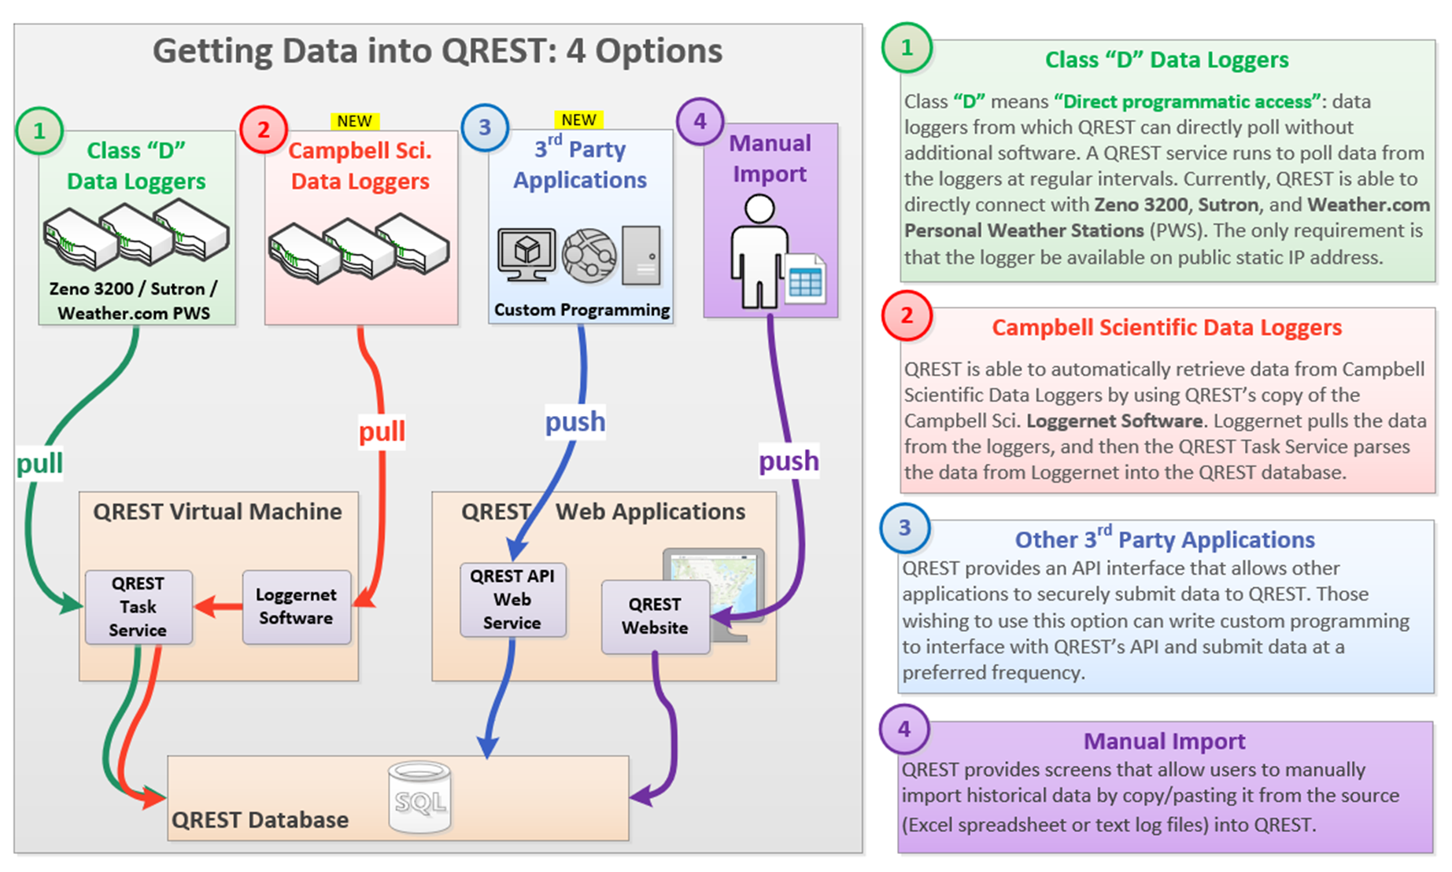

* + - 1. **Class “D” Data Loggers**. Class **“D”** means **“Direct programmatic access”**: data loggers from which QREST can directly poll without additional software. A QREST service runs to poll data from the loggers at regular intervals. See the list of **Supported Data Loggers**. The only requirement is that the logger be available on public static IP addresses.
      2. **Campbell Scientific Data Loggers**. QREST can automatically retrieve data from Campbell Scientific Data Loggers by using QREST’s copy of the Campbell Scientific **LoggerNet software**. LoggerNet pulls the data from the loggers and then the QREST Task Service parses the data from LoggerNet into the QREST database.
      3. **Other 3rd Party Applications**. QREST Provides an API interface that allows other applications to securely submit data to QREST. Those preferring to use this option can write custom programming to interface with QREST’s API and submit data at a preferred frequency.
      4. **Manual Import**. QREST allows users to manually import historical data by copying and pasting it from the source (Excel spreadsheet or text log files) into QREST.

## 1.5 Resources

Visit the following links for additional QREST resources and data management references:

* Tribal Air Monitoring Support (TAMS) Center Data Tools: <https://datatools.tamscenter.com/>, search:
  + QREST - generates list of QREST files for download
* Videos (YouTube playlist): <https://youtube.com/playlist?list=PLdtViTRnkGuqV24gJMwZAYvTay36EIVf0&si=QwAUpmxy6VUUbjlb>

# Getting Started

## 2.1 Roles and Responsibilities

There are four Tribal Agency Client roles in QREST; each holds different access levels and permissions. The design philosophy is to give control of all information to the Tribal Agency Administrator for that Organization. The following table summarizes the roles:

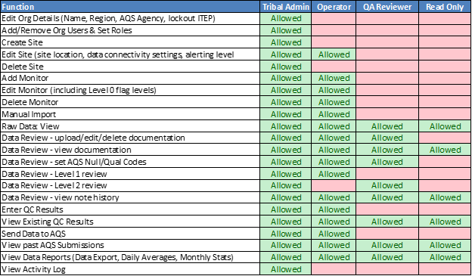

*Figure 1: QREST Tribal Agency Client Roles and Functions*

**ITEP-TAMS (Institute for Tribal Environmental Professionals-Tribal Air Monitoring Support Center) QREST Administrator:**

* The TAMS QREST Admins are responsible for (1) ongoing verification of QREST’s cloud database polling and logging operations, (2) maintaining QREST’s AQS Parameter/Method code tables to be consistent with those used by the US EPA AQS, (3) maintaining the QREST default CDX account for Tribal Agencies sending data to AQS, (4) funding the annual cloud storage and services fees, and (5) maintaining accurate documentation for Clients and Tribal Admins.
* When available and requested, the TAMS QREST Admins will collaborate with individual Clients to establish sites, monitors, polling/importing configurations and QREST’s pipeline to AQS for Client data.
* TAMS QREST Admins will not access any information (personnel, sites, monitors, and data) without explicit permission from the Tribal Agency managing that information. Verification of ongoing successful communication with the Tribal Client site is only done by the Global Administrator at the cloud database level, and it is the responsibility of the Tribal Agency to monitor that their data is being transmitted to QREST.
* In the advent of a request for Tribal Agency-specific information from anyone other than the Tribal Agency, the TAMS QREST Admin will inform the Tribal Agency and refer the requester to that Tribal Agency Admin.

**Global Administrator (OpenEnvironment)**:

* Maintains the operation of the cloud database and services, using TAMS Center funding.
* Communicates with the TAMS QREST Admin regarding cost estimates for QREST modifications to maintain communication with AQS and AirNow, and implementing changes as contracted by the TAMS Center.
* Collaborates with TAMS QREST Admins to maintain accurate QREST Admin documentation.

## 2.2 Registering an Account

Navigate to the **QREST Production home page (https://www.qrest.net/)** to register for a new Client account. If you are interested in using the **Test site** (recommended) sign up at <https://qrest-test.azurewebsites.net/Home/SignUp>.

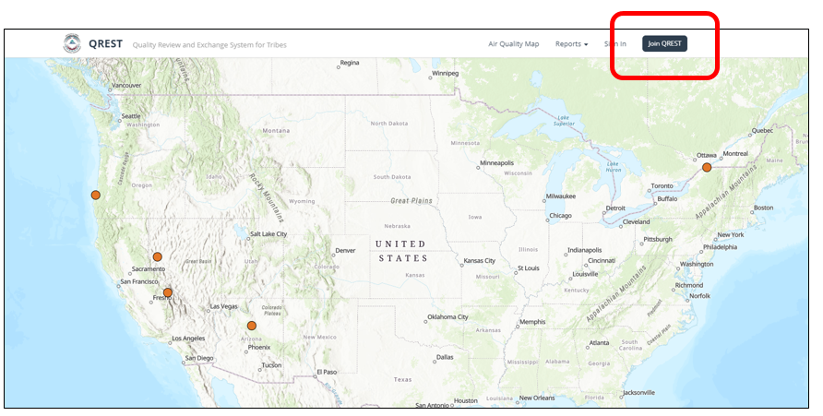

Click the **Join QREST** button to navigate to this page:

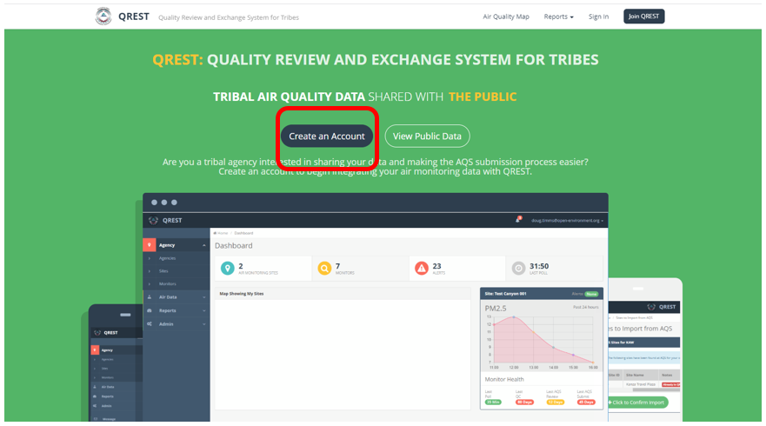

Click the **Create an Account** button to display the Registration page:

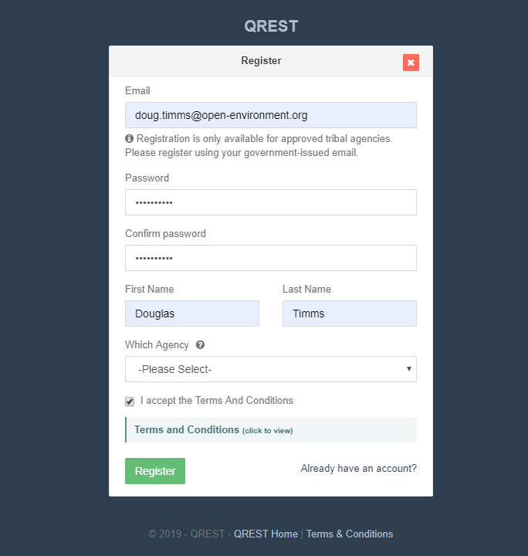

**Enter Registration Details:**

* Email address (must be unique, no two accounts with same email address)
* Password

|  |
| --- |
| Password Security Requirements |
| * Must be at least eight (8) characters in length |
| * Must consist of at least four (4) unique characters (e.g., AAABBBCC is not allowed) |
| * Checked against a list of the 100,000 most common passwords and rejected if using one of these common passwords. This security measure protects against common dictionary hacking attacks. |

* First and Last Name
* Tribal Agency: You can optionally supply a tribal agency/organization to be associated with. (You can also request to be affiliated with the ITEP Agency for training purposes.) Agencies appearing in the drop-down list are those who:

(1) are setup in QREST, and

(2) enabled Self-Registration for that Agency

If your Tribal Agency is not listed, the TAMS QREST Admin can add a new Tribal Agency by providing the Tribal Agency name and their EPA AQS code. After the TAMS QREST Admin adds the Tribal Agency, it will appear in the drop-down list of Agencies for new Client affiliation. When you request Tribal Agency affiliation, QREST sends an email notification to the Tribal Administrator(s) to approve the request and assign a Client type.

* Read and Accept the Terms and Conditions.

Click **Register**. The following screen will display, informing you that email verification is required:

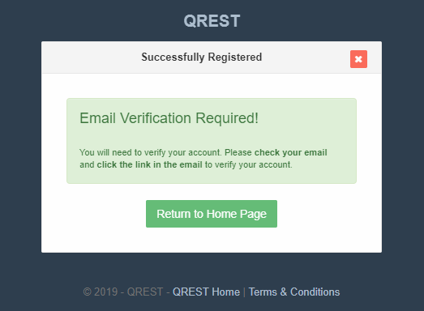

## 2.3 Email Verification

You will receive an email with a link to verify your email address. If you attempt to login to QREST prior to verifying your email, you will be unable to, and the following screen will display:

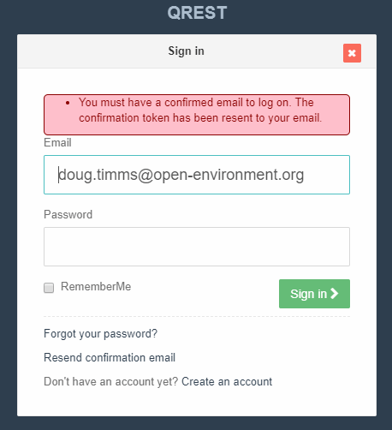

When you click the link in the verification email, the following screen will display:

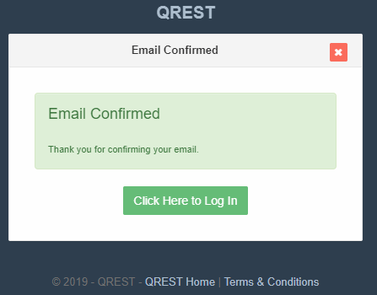

## 2.4 Logging In to QREST

After verifying your email account, log in to QREST at the Sign In page:

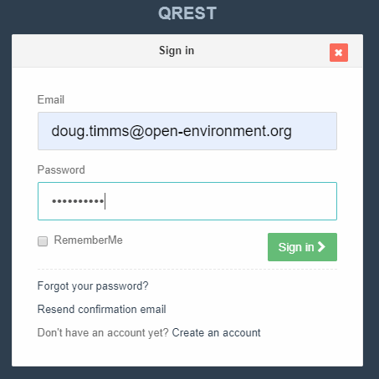

## 2.5 Retrieving Lost Password

Navigate to the Sign In page and click the **Forgot Your Password** link. Enter the email address that you originally registered your account with:

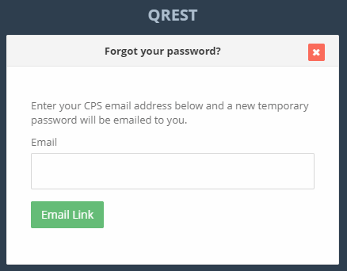

Click **Email Link** to receive an email with a link and follow the instructions in the email to reset your password. The link will expire within 24 hours.

## 2.6 Secure Dashboard

When you log in to the secure portal portion of QREST, you will see the QREST Dashboard as the landing page:

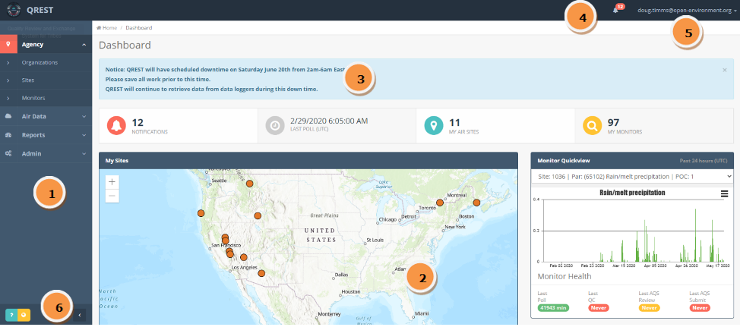

The dashboard consists of the following components:

**Left Navigation Menu:** provides access to most QREST functions.

**Main Dashboard Panel:** provides quick access and view to Site(s), Monitor(s), and other information. Clients can customize the Dashboard view, such as adding a preferred monitor (*My Favorite Monitor)* to display that monitor’s most recent 24 hours of data.

**Custom Message:** displays messages and announcements from QREST Administrators.

**Alerts (notifications):** displays the number of active alerts if the Client has *In-App Alerts* enabled in their Profile. When the Client clicks on the alert button (bell icon), it will show details and let them navigate to the alerts page to view more information.

**Top Header:** provides access to the Client’s Profile, Online Help, and logging out.

**Link to Public Site** and **Page-Specific Online Help:** provides navigation to the Public site (yellow globe icon) and the page-specific Online Help (blue question mark icon) when logged in. Online Help displays whichever page the Client is currently viewing in QREST.

## 2.7 Navigating QREST

Use the **breadcrumbs trail** at the top of each screen to navigate QREST and return to the Main Dashboard Panel (home page):

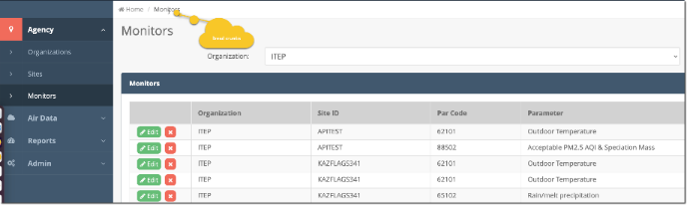

The **Left Navigation Menu** includes:

* **Agency** (location icon),
* **Air Data** (cloud icon), and
* **Reports** (analog dial icon).

You can expand or collapse these by clicking on the drop-down arrow next to the title.

If you are logged in as your Tribal Agency's Administrator (Admin), the Admin options are represented by the gear’s icon:

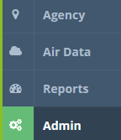

Minimize the left navigation menu by clicking on the arrow (<) at the bottom of the panel.

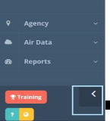

## 2.8 Saving Your Work

Panels that enable editing will prompt you to click before exiting the page. If you try to exit a page without saving, QREST will display the following:

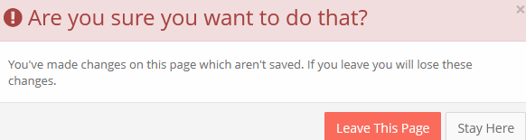

NOTE: the computer screen’s display may hide the bottom of the QREST page, where the Save button is located. To zoom out of the page, press the Control (ctrl) and minus (-) keys on your keyboard. To zoom in on the page, press the Control (ctrl) and plus (+) key.

# Tribal Agency/Organization Management

The TAMS QREST Administrator is responsible for creating the Tribal Agency/Organization record. After TAMS creates the record and assigns a Tribal Agency Admin, the Client can manage their information and data in QREST from then on. It is important that the Tribal Agency’s identifying information (e.g., their official AQS Tribal Agency and Screening Group names) are identical to the names as listed by the US EPA in AQS. The US EPA AQS Regional Liaison is responsible for providing this information to the Tribal Agency. The TAMS Center may also assist identifying the exact names and codes.

The **Agency > Organizations** screen lists all tribal agencies that the Client can access:

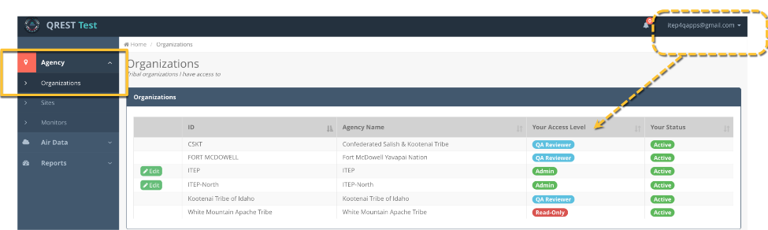

For each Agency/Organization the Client is affiliated with, the row displays the Client’s **Access Level** and **Status**. If the Client has Administrative access to the Agency, they can click the  button to edit an Agency.

## 3.1 Editing Your Tribal Agency/Organization

Click the **Edit** button to edit your Agency/Organization’s information:

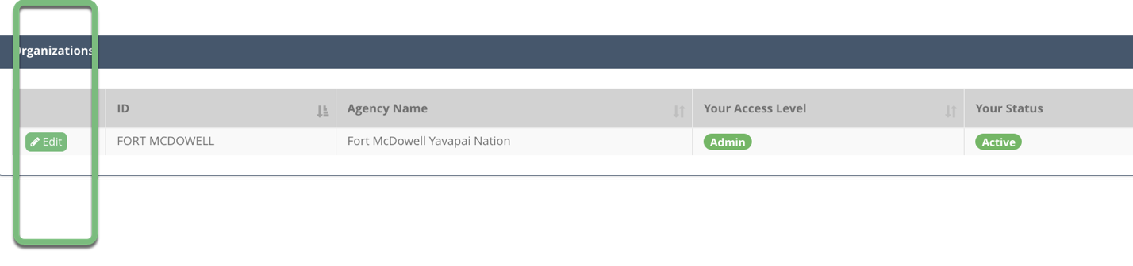Note that only Tribal Agency Admins can edit the Organization information. For example, if this Agency includes someone assigned a QA Reviewer role, or a Site Operator, they would not be able to edit Org, so that option does not appear for that role:

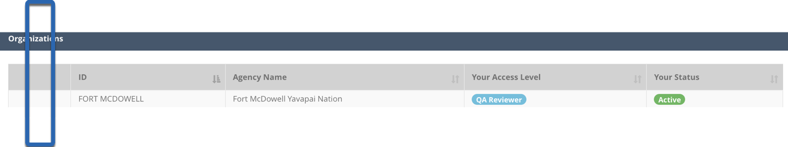Only the Tribal Agency Admin can edit the Organization, by clicking the green Edit button:

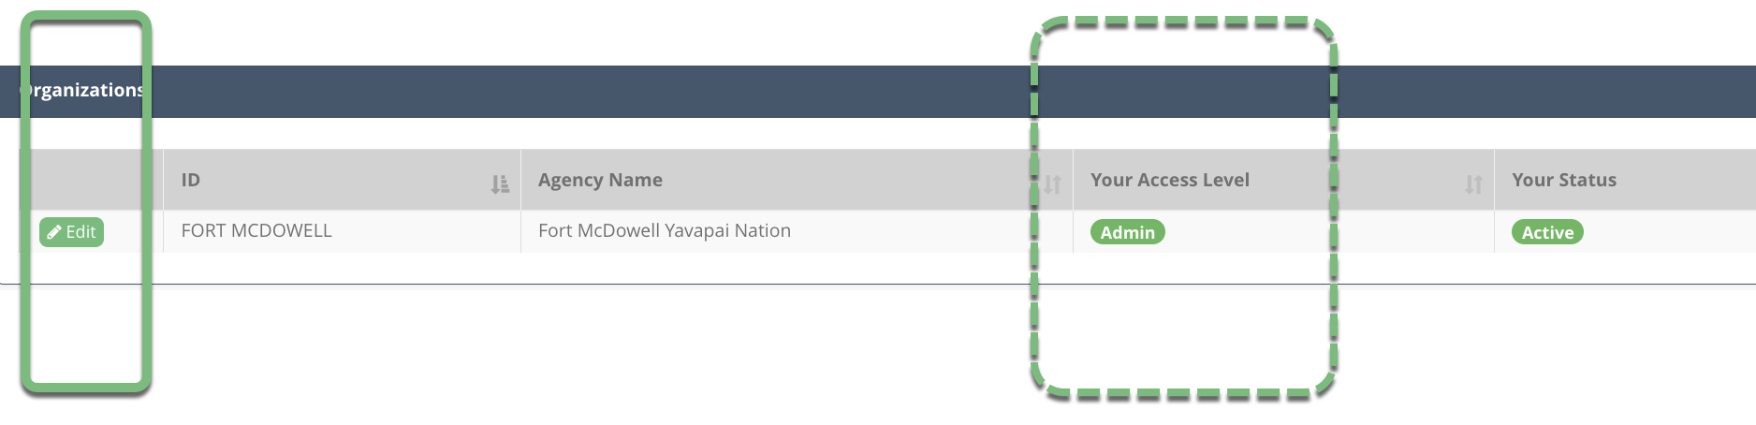

The Edit Organization panel includes critical information that should be determined by the Tribal Agency Admin, including a toggle setting that can be changed anytime that controls ITEP’s access of all information associated with this Agency, including data values. This button, shown in the yellow oval below, restricts access by the ITEP QREST Global Admins. If the Tribal Agency wants ITEP to access the information, such as for trouble shooting in collaboration with and by invitation from the Tribal Agency, then the Tribal Agency Admin just needs to uncheck this box. Also, this does not exclude access by the OpenEnvironment Global Admin (QREST’s developer) who maintains the cloud database.

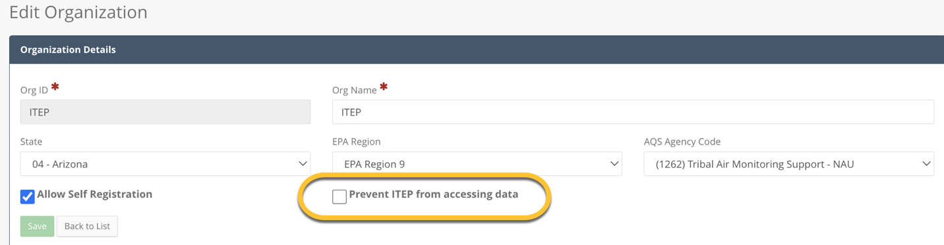

The other fields for the **Organization Details** pane include basic information about the Tribal Agency’s air program. Fields marked with an asterisk are mandatory and may be difficult to change later. Note that the reason for drop down selections in the other panels is because these codes need to match the codes in the US EPA AQS database if any of this data are eventually sent to AQS. Fields include:

* **Org ID** and **Name:** These do not need to be official Tribal Agency/Organization names, but information entered here is difficult to modify once saved. If the **Organization ID** and **Name** are already populated, verify that your Agency's information is correct.
* **State**
* **EPA Region**
* **AQS Agency Code:** by selecting an AQS Agency Code in QREST, you can import your site information directly from AQS if your tribe/organization has established sites in AQS. **IMPORTANT**: If there is an AQS Agency Code listed for your tribe/organization, verify that it is correct. Most federally recognized Tribal Agencies/Orgs are listed by AQS, but in some cases the US EPA must create a new code. If your Agency is not listed, please contact the TAMS Center Director, [christopher.lee@nau.edu](mailto:christopher.lee@nau.edu).
* **Allow Self Registration:** If this box is checked, the Agency/Organization appears in the drop-down list when new Clients register a new QREST account. This allows Tribal colleagues to request association with your Agency/Organization. If there are other individuals working with your data, they can request to be associated with your Agency. The Tribal Agency Admin must approve their request and their Role (Site Operator, QA Reviewer, or Read-Only).

**Organization Clients** pane**:** lists QREST Clients with access to the Agency/Org’s data.

* + **Access Level:** Indicates the Client’s access role for the organization. Refer to the Client Roles section for a full description of each access level.
  + **Status**:
    - Active
    - Pending
    - Rejected (equivalent to deleting the Client from the organization)

Verify that the Client accounts associated with your Agency are correct. Click **Edit** to the left of their name to update as needed.

Click on the 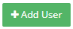 button to add a new Client and their Access Level to the organization.

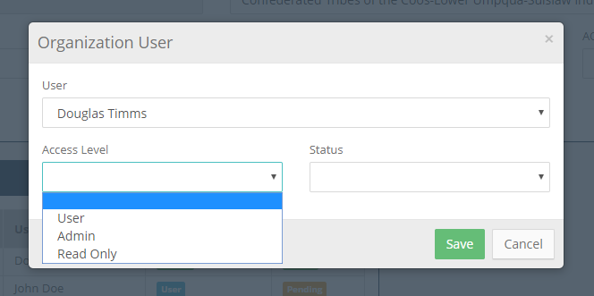

# Site Management

Some Tribal Agencies may already have site(s) set up in AQS. Current and correct AQS sites can be imported into QREST. If the Tribal Agency reports data to AQS, this will ensure that the site ID and other identifying codes in QREST match AQS expectations. Non-established AQS sites can be added directly in QREST as described in the Establishing Site Manually section.

It is good practice to verify what information AQS has for the Agency. If data is sent to AQS, it is necessary to obtain AQS login credentials, which are retrieved from the US EPA regional AQS contact (<https://www.epa.gov/aqs/aqs-user-support>).

## 4.1 Establishing Sites from AQS

Before importing your site information into QREST, first verify that it is correct in AQS. Log in to AQS at [**https://www.epa.gov/aqs**](https://www.epa.gov/aqs) and go to **Maintain > Site**.

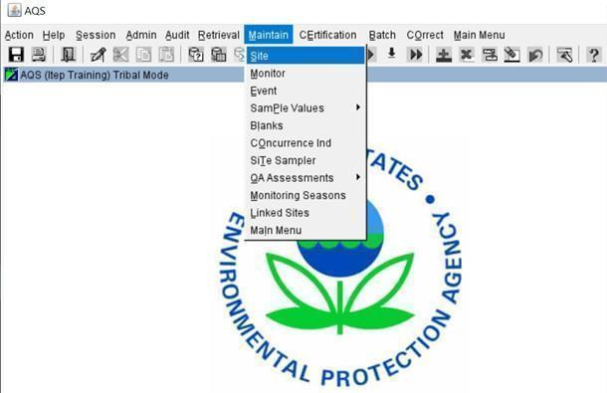

**IMPORTANT**: Long-established tribal agencies may have multiple sites in AQS, and some may be no longer operating. Verify that the site you import is correct and operational for the data you are working with. QREST will retrieve AQS sites based on the ***AQS Site ID, county*** and ***state*** entered on the **Site Edit** page – ensure that AQS Site ID is accurate before attempting import.

If the information is incorrect, or your site(s) is not set up in AQS, the US EPA has training material at <https://aqs.epa.gov/aqsweb/training/Training.html>. The TAMS Center also has videos on AQS at <http://bit.ly/AQS_fastrack> to assist you.

In QREST, navigate to **Agency > Sites** to import your site information into QREST from AQS:

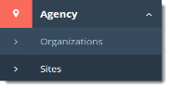

Click the **Import Sites from AQS** button in the Sites screen:

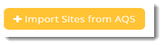

This opens a panel that lists sites associated with your Agency in AQS.

QREST will retrieve sites from EPA using the link: <https://aqs.epa.gov/aqsweb/codes/qa/SitesV4.txt>.

QREST will then display the Agency sites and prompt you to confirm if you want to import:

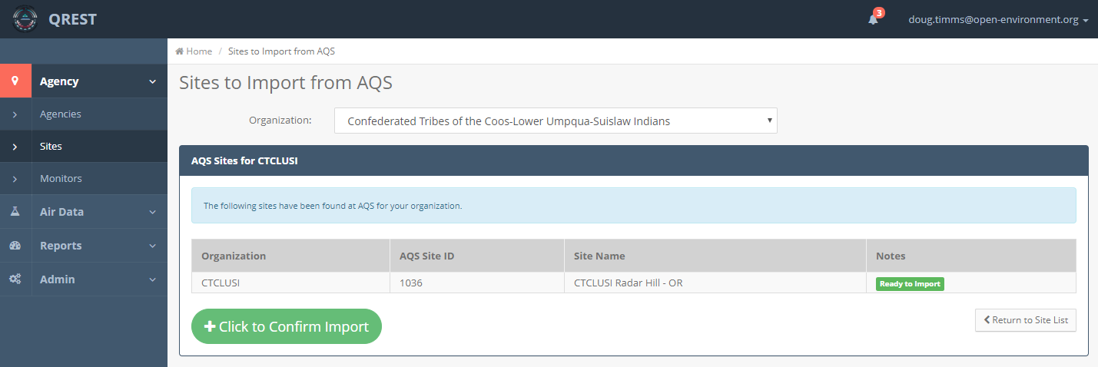

Click the  button to confirm the import for the site(s) that are appropriate for the Tribal Agency monitoring program.

## 4.2 Establishing Site Manually in QREST

If your Agency does not have site(s) established in AQS to be imported, then you can establish a site in QREST directly.

Navigate to **Agency > Sites**. You will see a list of sites that are accessible with your login credentials:

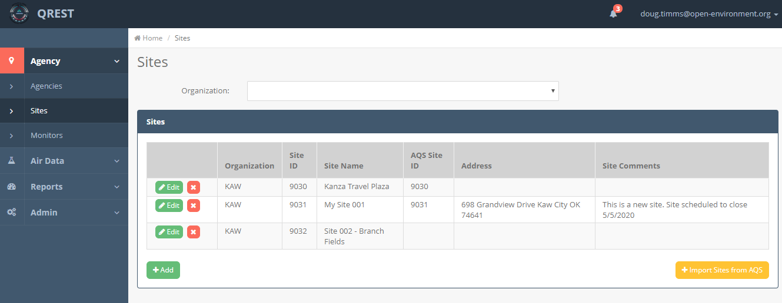

If there are no sites set up yet, you will see a blank table with headers.

* Click the 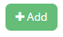button on the bottom left.
* **Enter the Site Details:** **Site ID, Site Name,** and **Organization** are important to enter correctly as they identify data in charts and tables. The QREST Site ID does not need to be the same as the AQS Site ID, but it may be convenient to use the same IDs:

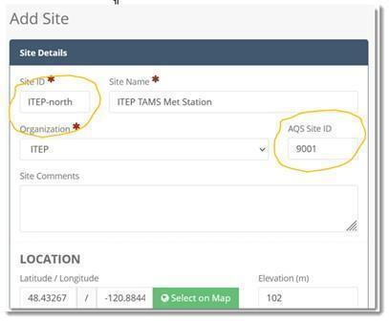

* You can manually enter the site location’s **latitude** and **longitude** coordinates or click the **Select on Map** button. Exact GPS coordinates are not necessary but will identify the site on the Public website map. The system will prompt with an error message if you attempt to save a latitude/longitude that falls outside of general U.S. proximity.
* Click your site’s location on the map. You can also enter the **elevation** and address information. Click **Continue** to save:

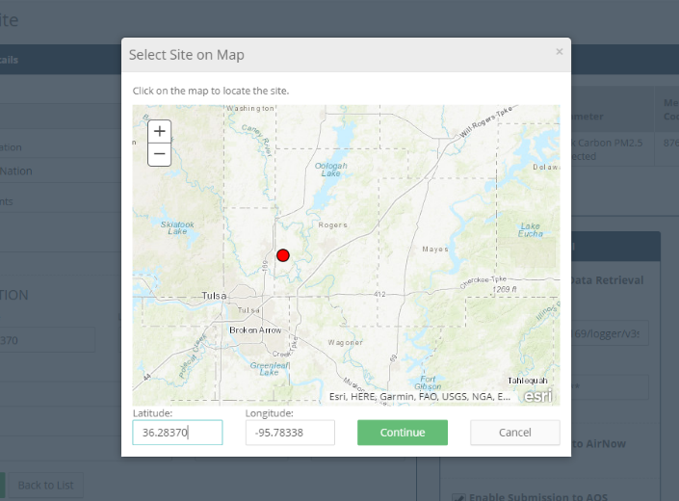

## 4.3 Supporting Documentation for Sites

Files relevant to the entire Site [e.g., photos, QAPP or QMP (Quality Management Plan), reports, videos] can be uploaded for secure and convenient storage. To add such site-applicable files, in the Edit Site panel, click on the green Upload button in the lower right of the Site Details screen:

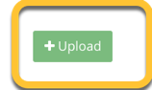

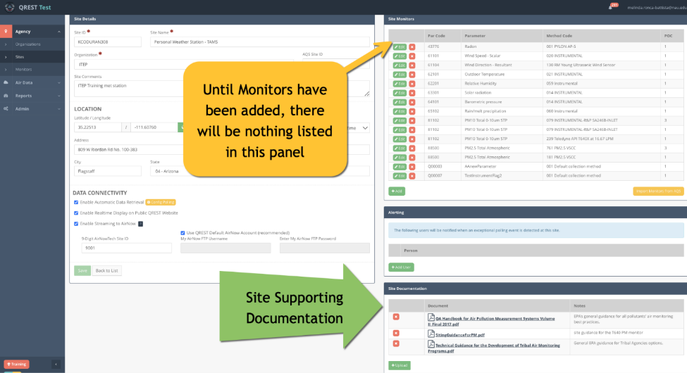

# Monitor Management

For each air collection site, a Client can define what parameters they are monitoring at that site. This includes identifying the parameter (i.e., pollutant), the unit of measure of collection, the method of data collection, etc. Each parameter such as wind speed, wind direction, and pollutant concentration are considered their own “monitors”, even if the data from multiple “monitors” is stored in the same data file. This is similar to the structure in AQS for “monitor” data as one particular parameter, and each site may have many “monitors.”

Like configuring Sites, QREST can import Monitor information from AQS if the monitors in AQS are correct for the data reported from that monitor in the Tribal Agency network. If there are no monitors set up in AQS, the monitor information can be added manually into QREST as described in the Establishing Monitors Manually in QREST section.

Basic tasks associated with a Monitor can be accessed by clicking on **Agency > Monitors**.

(Each monitor’s data and tasks can be accessed from the Sites page.)

## 5.1 Establishing Monitors via AQS Import

**IMPORTANT**: Long-established Tribal Agencies may have inactive monitors in AQS. Verify that the monitors you select are currently in use for your program. The owner’s manuals for monitoring equipment often lists method codes or they can be found on the manufacturer’s website. It is recommended to consult with the US EPA Regional AQS contact regarding the choice of parameter code or method code.

Navigate to **Agency > Sites** to access the Monitors page.

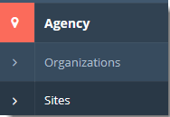

Or, if you already have monitors set up in QREST, navigate to **Agency > Monitors**.

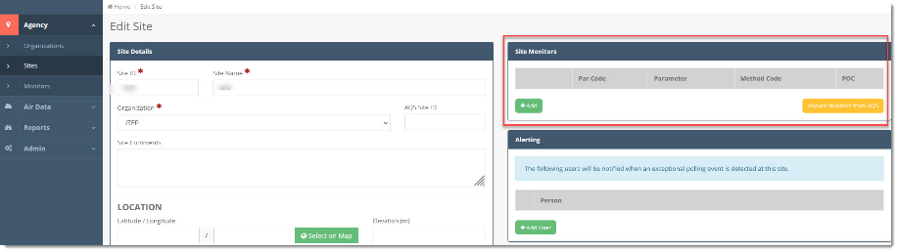

To identify monitors in AQS for import into QREST, specify the exact **AQS Site ID, county,** and **state**. If you edit or add information in the **Edit Site** pane, remember to click **Save** at the bottom of the panel. If these fields are incomplete, QREST will display an error message asking for this information needed by AQS.

QREST will query your Site ID in AQS and display a table of monitors with the parameter, method, and POC codes as they are listed in AQS. The API call for the monitors is located at <https://aqs.epa.gov/aqsweb/documents/data_api.html>:

https://aqs.epa.gov/data/api/monitors/bySite?email=**PAR1**&key=**PAR2**&bdate=20000101&edate=20251231&state=**PAR3**&county=**PAR4**&site=**PAR5**

Where:

* Par1 = AQS API username
* Par2 = AQS API password
* Par3 = The State defined for the Site on the Site Edit page
* Par4 = The County defined for the Site on the Site Edit page
* Par5 = The AQS Site ID defined for the Site on the Site Edit page

Note: QREST performs the translation of this API when it imports the site from AQS.

This will return data in JSON format that is parsed and inserted to the Monitors table:

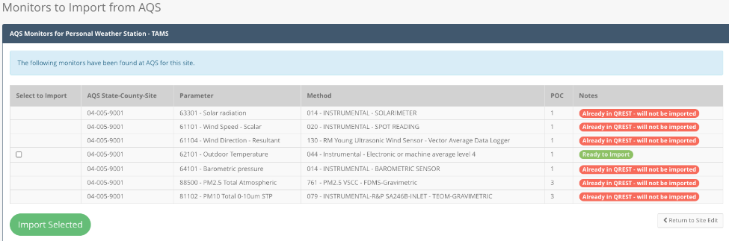

Check the boxes for monitors you want to import into QREST.

Click the **Import Selected** button. This will import the monitors and return to the previous screen, with the newly imported monitors listed.

## 5.2 Establishing Monitors Manually in QREST

If there are no monitors in AQS to import, or if there is a need to add a monitor directly into QREST, navigate to the **Agency > Sites > Edit** **Site** page.

Click the **Add** button in the **Site Monitors** pane:

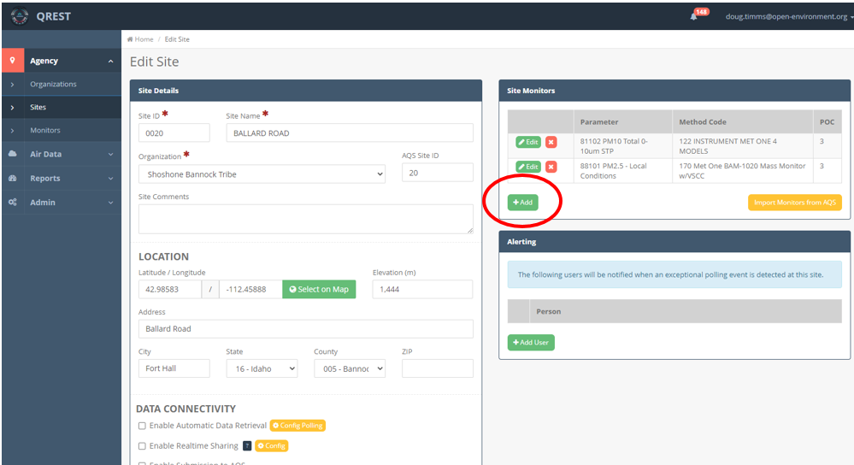

The Monitor Details pane will open.

Click the **+Search** button to Search and Select AQS Parameter/Method. (The AQS parameters listing is not easily searchable; for example, to find all PM2.5 methods, type “2.5” instead of “particulate”):

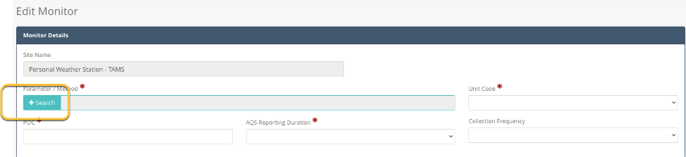

You can search parameters and methods by AQS parameter code, parameter name, or method code by typing in the search box:

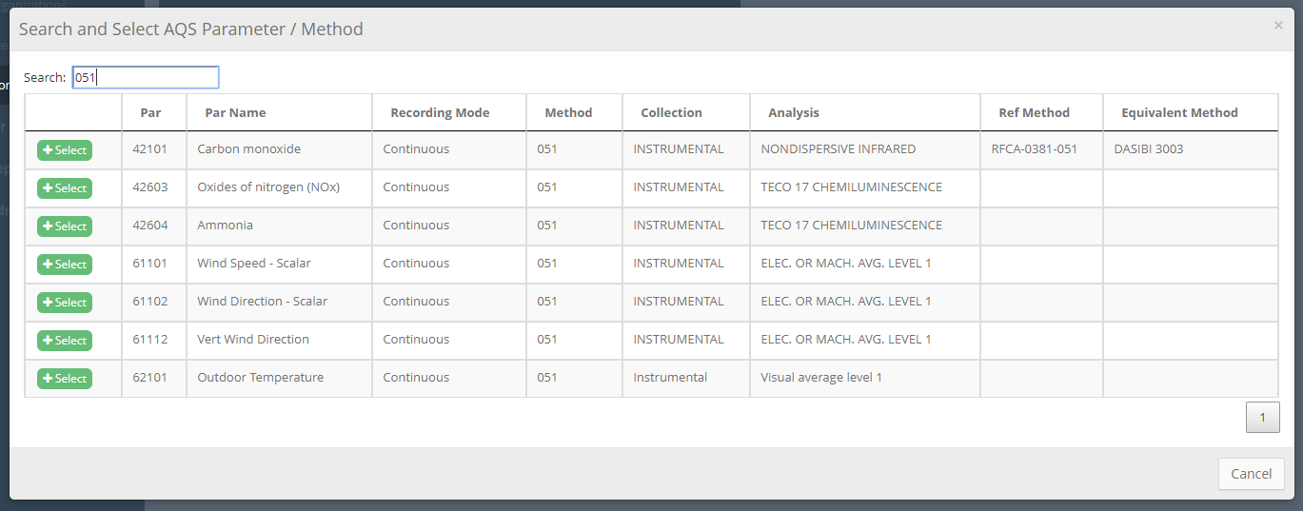

You can also enter text in the Search box if the text is identical to the AQS listing:

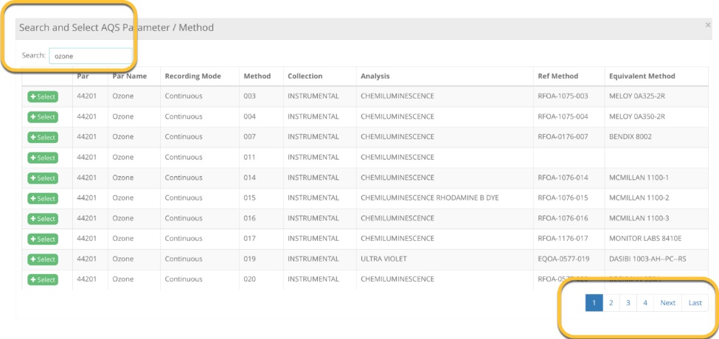

The results list may include multiple pages.

Click on the row that is appropriate for your equipment to select the combination of both parameter code and method code.

The first half of the Monitor pane will display. Enter the **POC, Unit Code,** and **AQS Reporting Duration** (1 hour for continuous monitors) for this data stream.

AQS will not accept data without this information. AQS does not require Collection Frequency.

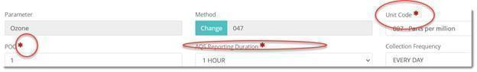

Note: QREST will flag as NOT SUITABLE FOR AQS until you include these for this monitor.

Click **Save**:

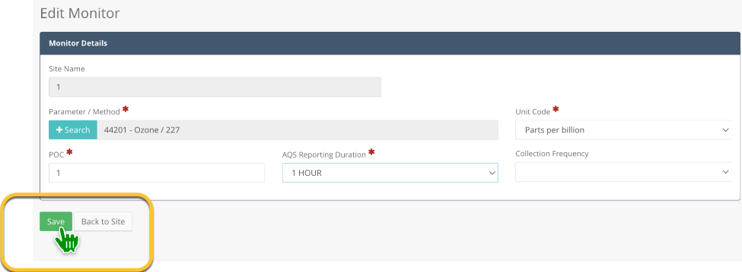

## 5.3 Level 0 Review Criteria and Alerts

Clients can define Level 0 (L0) criteria, or limits, for each monitor’s data. These criteria are used by QREST to check data when it is polled via the internet or manually imported. Most data management systems have machine checks that are termed *Level 0 Criteria* by the US EPA (<https://www.epa.gov/system/files/documents/2021-10/data-validation-guidance-document-final-august-2021.pdf>).

QREST uses Level 0 criteria in two ways:

* Automatically flags values that do not meet criteria. These flags do not invalidate data, but only identify the record (row) and color code in charts to be quickly identified during data review.
* Send alerts via text message or email to Agency personnel, if set in Notifications.

The **Alerts-Limits in Collection Units** pane is located under Monitor Details and opens after a monitor is saved:

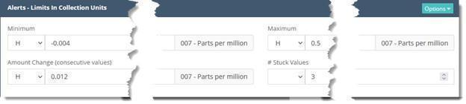

The L0 Criteria include:

* **Minimum value:** any values collected below this value is flagged.
* **Maximum value:** any values collected above this value is flagged.
* **Amount Change:** any consecutive (i.e., back-to-back) values with a difference more than this amount is flagged. For example, if two consecutive readings are 5 ppm and 16 ppm and the Amount Change limit is set to 8 ppm, the second value will be flagged because the difference (11 ppm) exceeds the specified amount change (jump) criterion.
* **# Stuck Values:** If selected, QREST will flag data where at least 3 consecutive records are identical.

Criteria can be set for either hourly data (H) or N-minute (such as five-minute) data, but not for both.

**Apply Default Alerts:**

Click on the **Options** button to open the drop-down menu and click on the **Reapply QREST Default Limits** button. Note: machine-derived limits may not be appropriate for your data.

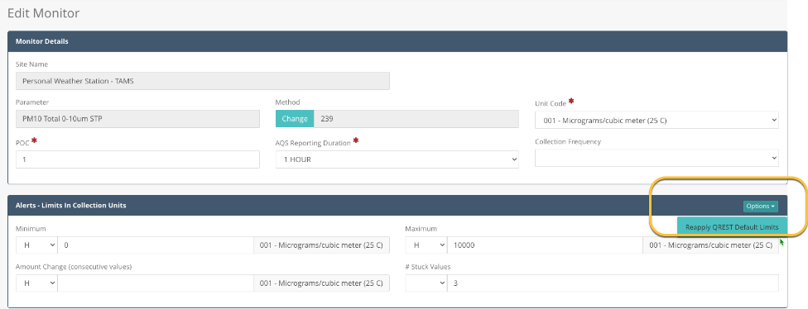

You can change L0 criteria as appropriate for conditions at the site, e.g., when seasons change or there is ongoing fire activity in the area.

## 5.4 Automatically Polled Data: Add Individuals to Receive Alerts

Tribal Agencies can assign personnel to receive alerts when polled data does not meet Level 0 criteria.

Click the **+Add User** button to add a Client.

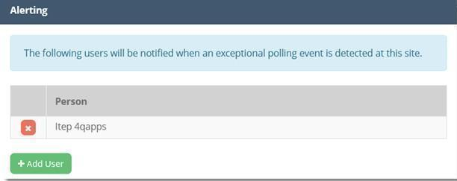

Click the **Delete (x)** button to the left of a Client’s name to remove them from alerts.

**Edit Your Alert Notifications:**

Click on your account **name** in the upper-right of the main header and select **Profile** to change your notification preferences.

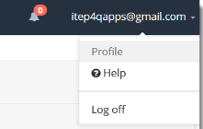

In the **My Profile** page, check the **In-App**, **Email**, or **Text Message Notification** boxes.

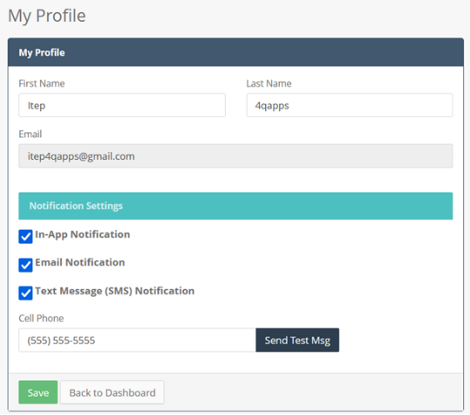

Click the **bell icon** in the main header to view the In-App Alerts/notifications:

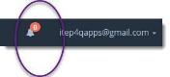

# Mapping Data to Monitors (Parameterization)

This section describes "parameterization," which is identifying the sequence of parameters and their units in the data for mapping into the QREST database. It is important to know the parameters being managed (wind speed, direction, air temperature, etc.) and their sequence in the data.

For example, five-minute data from a datalogger may look like this:



If you do not have documentation regarding the order of the parameters in the data, it may require investigation to determine the **value** of each parameter and their **units**.

In the example image above, the final value of 24.02 in the first row represents PM10 concentration in micrograms per cubic meter. There are other parameters in the data, including wind speed, direction, precipitation, and supporting equipment operational parameters.

The **date** and **time** are identified here (first field blurred for privacy):

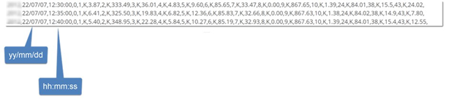

The **date format** is *yy/mm/dd* and is in the second field (value after the first comma).

The **time format** is *hh:mm:ss* and is in the third field (value after the second comma).

***Tip***: If your data includes meteorological parameters, look up current conditions at the nearest site where data are available. For example, search online for "weather near me" to get information from the national weather service such as:

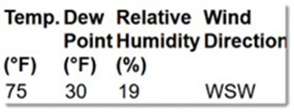

From these results, you can look through the fields in your data and determine which is temperature, and sometimes, relative humidity. For met data, wind direction is formatted in degrees (°). If you are familiar with the wind patterns at the site, and know that generally at this time of day the wind direction is coming from the west-south-west (WSW), you could look for values around 245 degrees. In most locations, barometric pressure is about 1010 millibars (mb), about 30 inches of mercury (Hg), or 760 mm Hg. Air pressure will not change much, so the value will stay about the same from one record to the next. (To convert units, visit <https://www.unitconverters.net/pressure-converter.html>.)

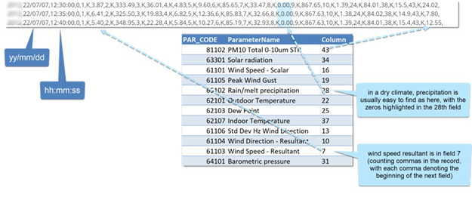After investigating, all parameters are mapped:

Reviewing the data and parsing out the parameter order is usually complete by looking at the raw data from the monitor, or the external data logger directly, using data logger support software or simple terminal programs. These allow users to extract information using a menu driven interface. For example, Met One Instruments supply users with a free copy of the Comet™ utility software used to retrieve data using either a direct serial connection or a remote connection via various modem types or even an IP address. Comet is a communications terminal program while other programs include Microsoft Windows® HyperTerminal, Crosstalk, Mirror, Microsoft Windows® Terminal, or ProComm®.

# Site-Specific Polling Configuration

QREST is designed so that *one site* is *one datalogger* connection. If a site has more than one datalogger or data input “stream,” then QREST will consider each to be its own site. All data from a site can be compared and combined in QREST tables, charts, and exports.

To retrieve data from loggers you need to first define a polling configuration.

Prior to completing a polling configuration, complete the steps in the Data Connectivity section:

**Data Connectivity:** you can turn on or off different data connectivity settings for this Site.

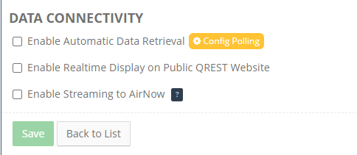

* **Automatic Data Retrieval:** check to enable QREST’s automated service to attempt to poll the Site according to the polling configuration currently defined for the site (see Polling Config section for more information about site polling configuration).
* **Realtime Display:** check to enable the Site’s appearance on the public website map.
* **Streaming to AirNow:** check to enable sharing of hourly monitoring data with EPA’s AirNow program.
  + **Option 1:** Check the **Use QREST Default AirNow Account** box if you want to be associated with the QREST network in AirNow. The TAMS QREST admin has this information for QREST Clients and can enter this information at your request. You can also find your site information by contacting AirNowTech at [info@airnowtech.org](mailto:info@airnowtech.org).
  + **Option 2:** Enter your **9-Digit AirNowTech Site ID**, **Username**, and **Password** if you want to use your own AirNow account. Your data can be sent to AirNow using either the built in AirNow account or your own.

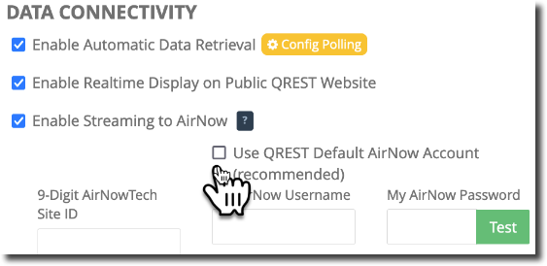

* **Site Level Alerting:** define which QREST Clients receive an alert/notification when this Site’s monitors fail the four automatic checks (valid ranges, record-to-record changes, stuck values, and non-numeric error codes). Notification types are set at your Profile screen, where you can select:
  + In-App Notification
  + Email Notification
  + Text Message (SMS) Notification
* **Site Monitors:** defines the parameters that are monitored at the Site.
* Click **Save** at the bottom of the Site Details panel. You can now either return to the Site List by clicking **Back to List** or begin the process to Import or Add Site Monitors, described in the Monitors section.

## 7.1 QREST Polling and Calculations Tasks

You can use QREST without automated data retrieval if you use only the manual data upload feature. However, many Clients use telemetry to retrieve their data via the internet. This section describes communicating with the datalogger.

QREST runs a Polling Task at predefined frequencies and performs the following tasks each time:

1. Retrieves the list of sites configured for polling in QREST.
2. Retrieves data for each site:
   1. Establishes a connection with the remote data logger for the site.
   2. Retrieves the last X records logged at the site.
   3. Terminates communication with the data logger.
3. Parses, validates, and writes data for each site:
   1. Parses the text file coming from the data logger according to the Site’s Polling Configuration (i.e., identifying which columns map to which parameters).
   2. Sends out n-minute alerts if defined for the monitor (for example, if the n-minute record value is higher than the alert level set for that monitor).
   3. Inserts the n-minute record to the QREST database.

## 7.2 QREST Alert Notification Task

QREST will run hourly Alert Notification Tasks to validate any new or updated data. The Alert Notification Task:

1. Selects all hourly records for alert notification tasks that have not run yet.
2. For each of the selected hourly records, performs the following:
   1. **Lost Data:** Inserts missing hourly records for any missing hours. For these records, writes the “LOST” data flag.
   2. **Min Violation:** Writes the “MIN” validation code for any records below the minimum alert level for the monitor.
   3. **Max Violation:** Writes the “MAX” validation code for any records above the maximum alert level for the monitor.
   4. **Data Jumps:** Writes the “JUMP” validation code for any records with an amount change from the previous hourly record that exceed any alerts set for the monitor.
   5. **Stuck Values:** Writes the “STUCK” validation code for any records with repeating hourly values that exceed any alerts set for the monitor.
   6. **Removal of LOST flag:** for any values that have had a numeric value retrieved but were previously flagged as “LOST,” the “LOST” flag is removed.
3. Finally, the VAL_IND for these records is set to 1, indicating that the record has been validated and does not need to be validated again.

## 7.3 Specify Polling Config

Navigate to **Agency > Sites > Edit** **Site**. In the lower-left under Data Connectivity, click the **Config Polling** button:

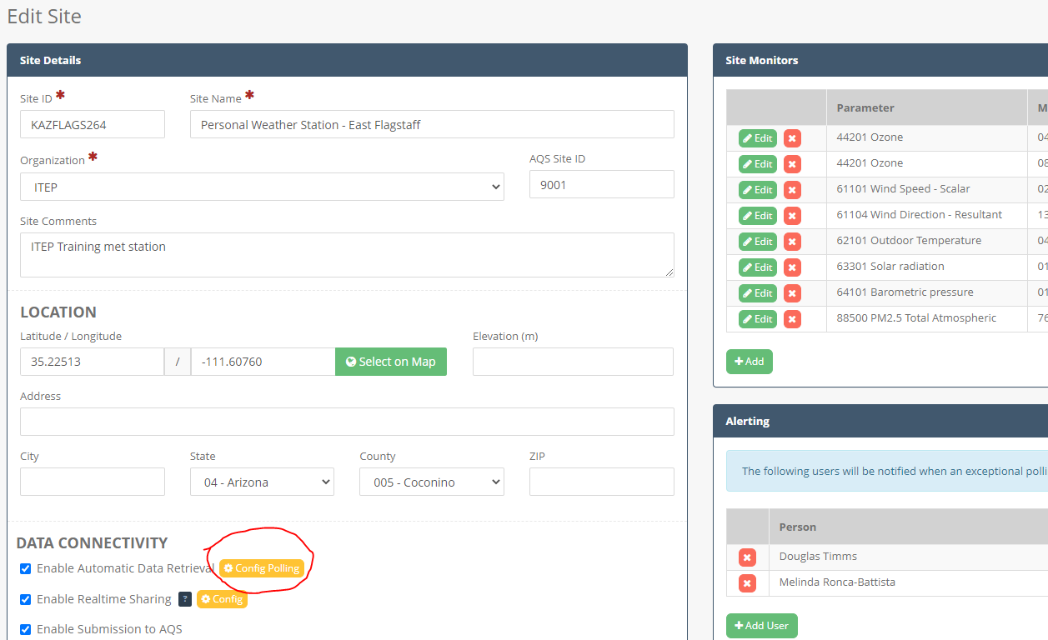

The **Site Poll Config** pane will open, and you will see a row with a **+Add Polling Config** button (if you are accessing it for the first time):

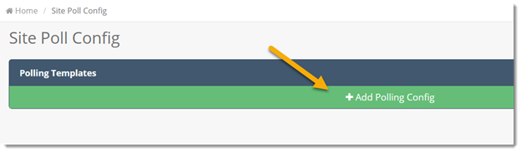

Click **+Add Polling Config** to edit the **Connectivity** details:

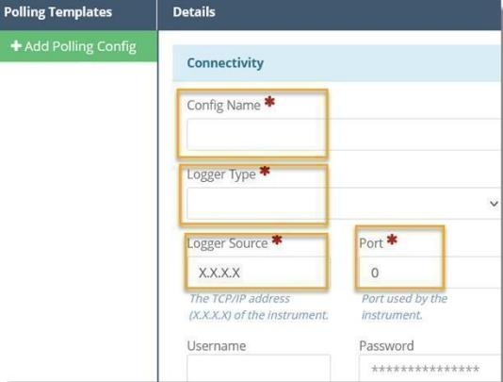

Entering the following fields:

* **Config Name:** give your polling configuration a descriptive name. (A site may have seasonal or other polling configurations, and the **Config Name** will help distinguish different configurations.)
* **Logger Type:** 
  + **Zeno** (for a Zeno 3200 data logger with an available IP-based connectivity)
  + **Sutron** (for a Sutron XLite data logger with an available IP-based connectivity)
  + **Campbell Scientific Data Loggers** (TCP/IP via LoggerNet support software)
  + **Agilaire 8872 Data Logger** (TCP/IP via logger ID and command script)
  + **ESC 8816 and ESC 8832 Data Loggers** (TCP/IP via logger ID and command script)
  + **Met One Instruments BAM 1020 & BAM 1022** (access monitors internal data loggers using TCP/IP via command script, or HyperTerminal)
* **Logger Source:**
  + **Zeno/Sutron:** enter the public IP address (e.g., XXX.XXX.XX.XX) where the logger is located.
  + **PWS:** provide the name of the weather station, as published at api.weather.com. The Logger Source should be the station ID that would replace the XXXXXX in the following link: [https://api.weather.com/v2/pws/observations/current?stationId=**XXXXXX**&format=json&units=e&apiKey=YYYYYYY](https://api.weather.com/v2/pws/observations/current?stationId=XXXXXX&format=json&units=e&apiKey=YYYYYYY).
  + **Campbell Scientific,** **Agilaire 8872, ESC** and **Met One** loggers cannot be configured directly by the Tribal Client. Tribal Agencies must meet with a QREST Admin to configure these connections, often with the Tribal Agency IT department.
* **Port:** destination port for data retrieval (required when connecting to Zeno / Sutron loggers)
* **Username:** if logger requires a username to retrieve data. For Zeno loggers, this is not used.
* **Password:** if logger requires a password to retrieve data.
  + For **Zeno** loggers, this is the Level 1 password.
  + For **Weather.com** this is the API Key for the Weather Company web service

After saving a Site Poll Config, the **Data Format** pane opens. (Note: you cannot edit this pane if polling is online. If polling is online, scroll to the bottom of the pane and click **Take Offline and Allow Editing**. *You will need to turn it on again to resume Polling.)*

Enter the:

* **Sample Duration:** time interval that the logger outputs data. If set to “5 MINUTE”, QREST will retrieve the 5-minute data and calculate hourly data from the 5-minute raw data. Otherwise, QREST will retrieve the hourly data from the logger and store it.
* **Delimiter:** How columns of data are separated in the logger output file. Comma separated values are the typical format from automatic polling (manual import config - Setting Up and Import Template section).
* **Local Time Zone:** the time zone where the site is located.
* **Date/Time Output Type:** identifies data output on the data logger, either in local standard time or UTC time.
* **Date Column:** Column number in which date is stored.
* **Date Format:** Format of DATE field on data logger file.
* **Time Column:** Column number in which time is stored.
* **Time Format:** Format of TIME field on data logger file.

Click **Save**.

## 7.4 Assigning Columns for Automated Polling

QREST lists monitors assigned to a site, which must be “mapped” to a column in your data.

(The process of mapping data columns to the correct parameter is sometimes referred to as “parameterization.” See the Mapping Data to Monitors (Parameterization) or Pinging Logger for more information.)

If you have not added any monitors to the site, no monitors will be available and you will need to either Establish a Monitor via AQS Import or Establish a Monitor Manually in QREST.

Navigate to Sites to edit the polling configuration:

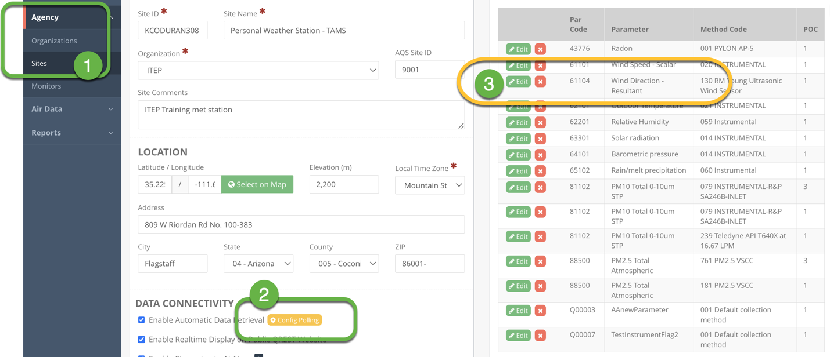

Click **Add** to open the **Edit Setting** box. Select one of the **Monitors** assigned to this Site from the drop-down menu:

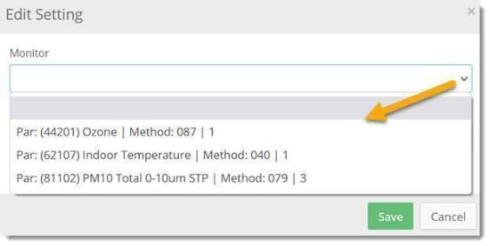

(Note: QREST uses the term "monitor" in the same way that AQS does, as a parameter. The selection in QREST includes method code, parameter code, and POC because AQS requires these values.)

Enter the **Column** number (numeric value)in which the parameter appears in the data logger file.

*Below is an example data file produced from a data logger In this case, Wind Direction is configured in your Zeno logger on Channel 2 (in red below). The column value would be* ***10*** *because the Wind Direction values above (221.50, 225.80, 218.70, 221.00, 226.00) appear in the* ***10th column****:*

1128,20/06/19,02:45:00,0,1,K,4.20,**2,K,221.50**,3,K,21.40,4,K,4.40,5,K,8.70,35,K,16.2488

1128,20/06/19,02:50:00,0,1,K,5.60,**2,K,225.80**,3,K,15.70,4,K,5.80,5,K,9.00,35,K,17.9745

1128,20/06/19,02:55:00,0,1,K,5.50,**2,K,218.70**,3,K,17.30,4,K,5.70,5,K,9.50,35,K,16.0348

1128,20/06/19,03:00:00,0,1,K,5.50,**2,K,221.00**,3,K,16.50,4,K,5.70,5,K,8.90,35,K,11.7177

1128,20/06/19,03:05:00,0,1,K,5.40,**2,K,226.00**,3,K,17.60,4,K,5.50,5,K,8.90,35,K,9.4351

**1 2 3 4 5 6 7 8 9 10**

*(Note: if you are retrieving data from a weather.com weather station, the column numbers are ignored.*

Continue in the Edit Setting pane and complete the following:

* **Summary Type:** select a calculation type for QREST to summarize n-minute data from the logger into hourly data. If the data being pulled from the logger is hourly (or if this is a weather.com weather station), then this is ignored. Note: precipitation should be summarized by Total (Sum) for the hourly statistic.
* **Rounding Decimals:** enter the number of decimal places to use when calculating hourly data from n-minute data coming from the logger.
* **Adjustment Factor:** enter a number if data values need adjustment before storing in QREST. For example, if the data logger outputs Ozone in *Volts* but you want QREST to store Ozone in *parts per billion*, enter an adjustment factor of *500* (Volts to ppb x 500).
* Click **Save**.

### 7.4.1 Polling Configuration Locking, Editing, and Change Log

After you save a polling configuration and set it to **Active**, it is locked. To make subsequent changes, click the **Take Offline & Allow Editing** button. This will set the Polling Configuration into edit mode. You can then edit and write notes to describe the changes you are making. Additionally, QREST will record and log each field change.

View a complete history of all changes made to the Polling Configuration under the **Options > View Change Log** menu:

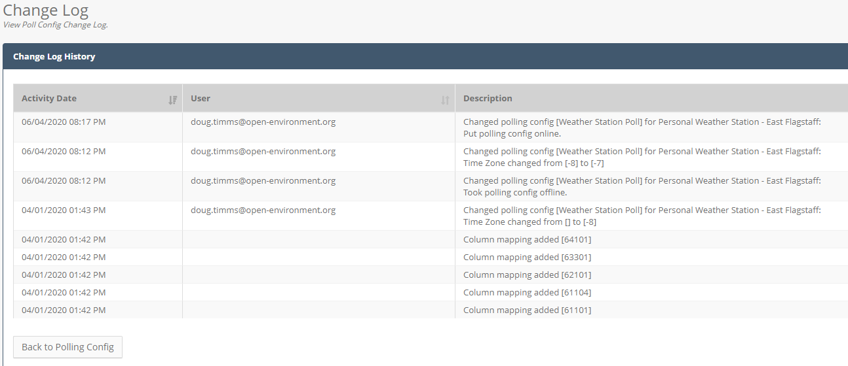

### 7.4.2 Deleting a Polling Configuration

Delete a Polling Configuration by first setting it to Inactive. Click the **Take Offline & Allow Editing** button. Then, access the Delete option from the **Options** menu.

### 7.4.3 Pinging Logger

QREST can evaluate data logger connectivity by pinging the connection. This feature can also identify the format, or sequence, of values in your data. This is useful in verifying proper configuration of the connection details (IP address, port, and if needed username and password) in QREST.

Navigate to the **Site Poll Config** page. Click the **Options** button and **Ping Connection** from the drop-down menu:

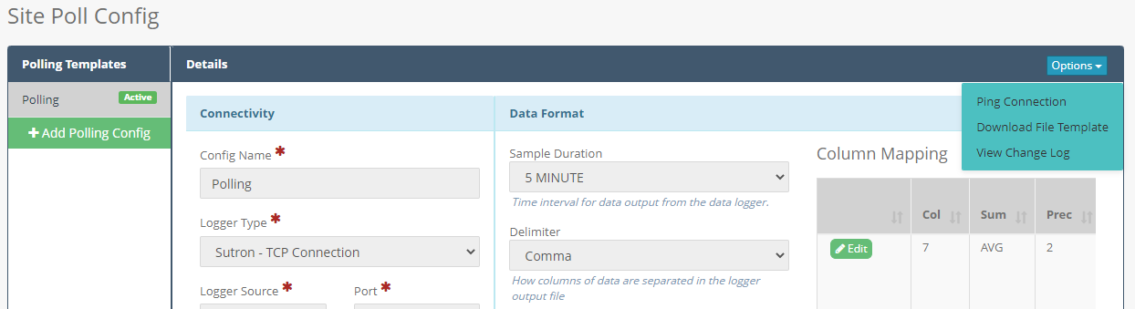

There are two ping options:

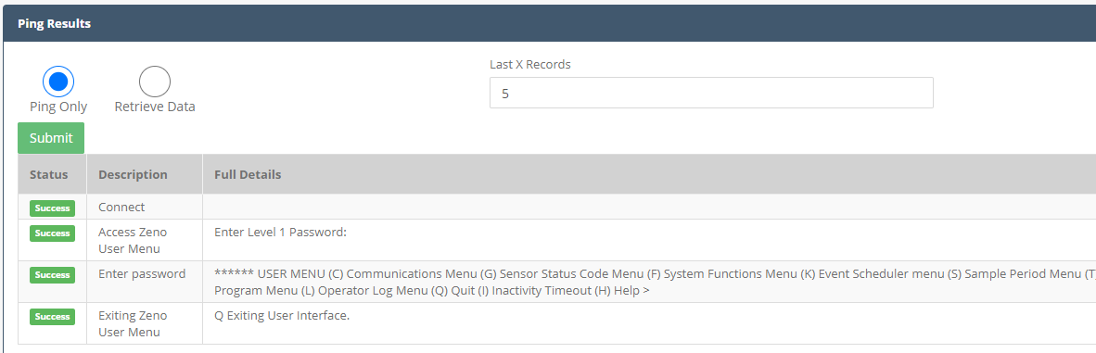

* **Ping Only (available for Zeno loggers only):** Will attempt to establish a connection with the data logger and if successful disconnect from the logger. If the test is successful it will look like the table in the image above.
* **Retrieve Data (available for Zeno, Agilaire, MetOne BAMs, and Sutron loggers only):** Will attempt to establish connection with the logger and download a small set of data. Specify the number of data records to retrieve in the **Last X Records** textbox. Results of the ping/retrieval will display:

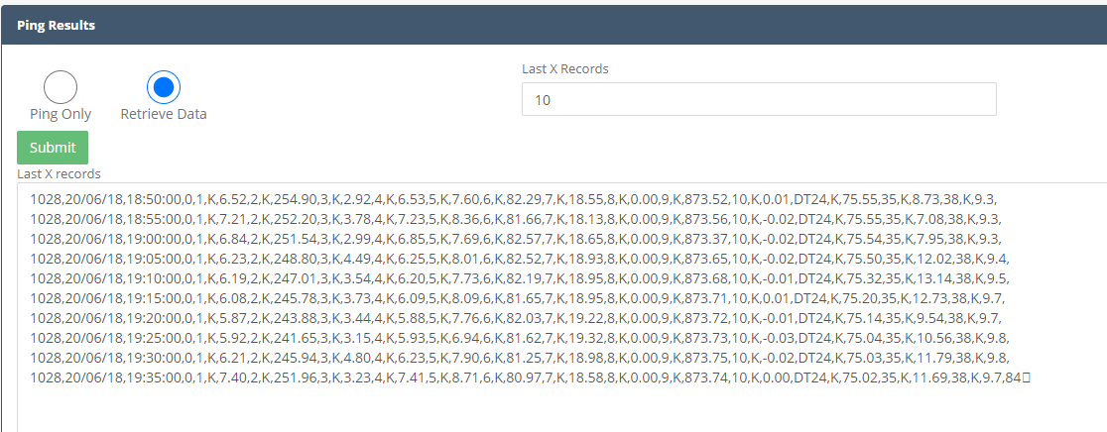

* The last N records from the datalogger will display. You may complete this repeatedly to identify which column (order) is what parameter, identify the format of date and time, etc.
* **Manual Poll and Store (available for Weather.com weather stations only):** Will retrieve data from weather station and store the hourly data. Use this option if you want to pull data immediately and not wait for the QREST scheduled task to retrieve data.

Click **Back to Polling Config** to return to the **Site Poll Config** pane.

# Air Data Management

This section reviews how to use QREST to view n-minute or hourly data in the charts and tables. The Raw Data feature can be used by Clients associated with the Tribal Agency, including Read-Only clients.

## 8.1 QREST Calculations on N-Minute Data

When a record is inserted or updated in an n-minute data table, QREST completes the following:

* Lookup the **summary type**, **local time zone** and **decimal places** defined for this parameter at this site (defined by the Clients in the polling configuration).
* Calculate (or recalculate, if records were updated) the hourly summary for the hour in which that n-minute record belongs, rounding to the specified precision.
* Add up the number of records that exist in QREST for the hour in which that n-minute record belongs.
* If less than 75% of records for the hour are in QREST, then replace the calculated summary with the code “FEW.”
  + Store the calculated hourly record, storing both the raw UTC time and the local time.

## 8.2 QREST Alert Notification Task

Every hour, QREST reviews any new or updated data, including polled or manually imported data, and evaluates the data against the Level 0 criteria (max, min, jump, stuck, missing). These checks, which apply to both imported and polled data, are described in section 7.2.

## 8.3 Manual Raw Data Import

You can upload hourly or five-minute raw data into QREST in situations where automatic polling is not configured, to fill in historical or lost data, or to make bulk corrections to data. Tribal Agencies may have data in other databases (such as AQS) and use QREST to manage and summarize the data.

It is also common to have data from various sources; data directly from your analyzer may be comma delimited, and data directly from your datalogger communication program may be in a different format. In QREST, you can set and save different Import Configuration (Configs) for these different formats. You can also set Import Configs to import date and time from separate or the same field.

You must establish Sites and Monitors to accept data, otherwise, data cannot be imported into QREST. Additionally, specify an import configuration so that QREST can identify which column represents data from which monitor. Headers are not imported into QREST, only the values, so “mapping” is necessary to specify in the import config.

### 8.3.1 Types of Data Files

QREST can import various file types, but all files are either comma delimited or tab delimited:

* A file is ***comma delimited*** if it consists of rows of data with multiple commas separating values. This is common for data exported from dataloggers.
* A file is ***tab delimited*** if it is an Excel file or if it opens in a columnar format.

Some data files can be viewed by Command (cmd)-, Control (ctrl)-, or right-clicking on the file and opening with WordPad, Notepad, or another text viewer.

**Types of Data Files with examples** *(the data to be imported is highlighted in yellow):*

**Hourly Data of 1 parameter, where each hour’s results arranged as 24 columns** -- often seen data exports from datalogger communication software and represents hourly values for one parameter. Each row is an entire day with 24 columns, one for each hour:

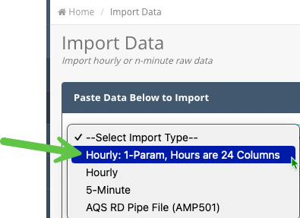

Below is an example of this format with each hour’s value separated by a comma:

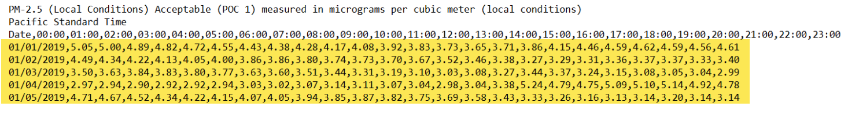

**Hourly Data, with different parameters in different columns --** includes multiple parameters, some or all of which can be imported into QREST if they are “mapped” to a monitor. If columns are not mapped to a monitor in QREST, they are skipped by QREST in the import.

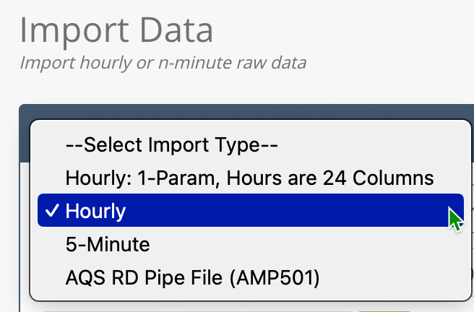

Below is an example of this format:

01/01/2006,00:00,21.733,3.692,2.590,15.065,11.300,44.246,46.100,68.792,56.417,962.960,0.000

01/01/2006,01:00,21.767,4.858,1.595,297.879,9.400,66.381,44.600,68.208,57.750,962.785,0.000

01/01/2006,02:00,25.900,4.683,2.138,327.455,10.600,59.709,44.500,67.533,57.667,963.433,0.000

Another example of this format includes headers to identify parameters (*imported data should not include headers* but are useful when setting up manual or polled data configurations):

Time ConcRT ConcHR flow WS

07/06/2020 12:00 25 71 13.3 4.1

07/06/2020 13:00 26 19 16.6 4.7

07/06/2020 14:00 29 15 16.6 4.6

Another example:

date,time,pm10_MC

01/18/2020,20:00,37.68

01/18/2020,21:00,44.16

01/18/2020,22:00,29.52

01/18/2020,23:00,14.64

**5 Minute comma delimited data, with different parameters in different columns** --

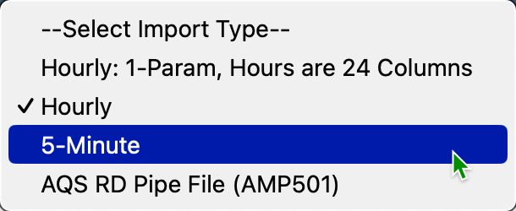

Below is an example of this format with data from multiple parameters in each row:

01/01/2001,00:00,21.733,3.692,2.590,15.065,11.300,44.246,46.100,68.792,56.417,962.960,0.000

01/01/2001,00:05,21.767,4.858,1.595, 297.879,9.400,66.381, 44.600,68.208,57.750,962.785,0.000

01/01/2001,00:10,25.900,4.683,2.138,327.455,10.600,59. 709,44.500,67.533,57.667,963.433,0.000

01/01/2001,00:15,22.983,3.517,1.087,30.347,9.400,67.321,45.442,67.092,56.417,963.907,0.000

01/01/2001,00:20,21.708,3.625,2.377,5.851,6.200,47.529,43.342,66.758,63.083,963.911,0.000

Another example:

date,time,ConcRT,ConcHR,flow,WS,WD,AT,RH,BP,FT,FRH,BV,PM,Status

07/06/2020,12:05,14,71,13.3,4.1,234,32.4,6,651,33.8,4,12.5,l,256

07/06/2020,12:10,16,19,16.6,4.7,242,33.1,6,651,36.8,4,12.5,l,0

07/06/2020,12:15,15,15,16.6,4.6,253,34,6,651,37.9,4,12.5,l,0

**Hourly tab delimited data --**

Tab delimited formatted data often opens by default in Excel and has no commas in the data file. Instead, each value is in a width-aligned “column” and values are separated by spaces:

11/01/2020 00:00:00 36.5 0.96

11/01/2020 01:00:00 27.522 0.57

11/01/2020 02:00:00 40.5724 0.18

11/01/2020 03:00:00 32.466 0.59

11/01/2020 04:00:00 30.2583 1.46

11/01/2020 05:00:00 19.8438 0.65

11/01/2020 06:00:00 24.4889 0.71

11/01/2020 07:00:00 29.7181 0.18

11/01/2020 08:00:00 54.4559 0.33

This data type can be imported as is by copying from Excel (or WordPad or Notepad) and pasting into the import window.

**5-minute tab delimited --**

Five-minute tab delimited data looks like hourly tab delimited data, but each row is a new 5-minute record:

07/06/2020 0:00 0.032

07/06/2020 0:05 0.035

07/06/2020 0:10 0.038

07/06/2020 0:15 0.045

Another example:

|  |  |  |  |  |  |  |
| --- | --- | --- | --- | --- | --- | --- |
| 06/03/24 00:15 | 06/03/2024 07:15:00 | 100.265523 | -62.494562 | 2.9792 | 1.01669 | 1.96251 |
| 06/03/24 00:20 | 06/03/2024 07:20:00 | 100.264282 | -62.509156 | 3.22981 | 1.1381 | 2.09171 |
| 06/03/24 00:25 | 06/03/2024 07:25:00 | 100.27039 | -62.482209 | 3.25869 | 1.18845 | 2.07024 |
| 06/03/24 00:30 | 06/03/2024 07:30:00 | 100.252748 | -62.502194 | 3.30562 | 1.26122 | 2.0444 |
| 06/03/24 00:35 | 06/03/2024 07:35:00 | 100.263852 | -62.476318 | 3.01511 | 1.08756 | 1.92755 |
| 06/03/24 00:40 | 06/03/2024 07:40:00 | 100.251733 | -62.495393 | 3.00998 | 1.16071 | 1.84927 |
| 06/03/24 00:45 | 06/03/2024 07:45:00 | 100.25071 | -62.512412 | 3.10935 | 1.23557 | 1.87378 |

### 8.3.2 Setting Up an Import Template

If you are importing data manually, you will need to set up an Import Template (Import Configuration), which tells QREST what parameters to expect in each column.

Navigate to **Air Data > Manual Import**:

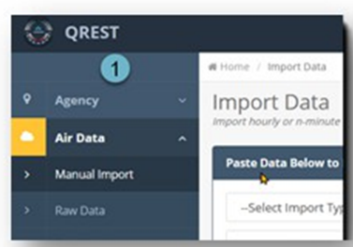

Select the **Data Format Type**:

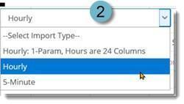

Select your **Agency** and **Site**. Click the **Add (plus icon)** to create a new Import Config (if you have not defined one yet). To revise an existing import config or verify that it will work with the data you are importing, click **Edit (pencil icon)**:

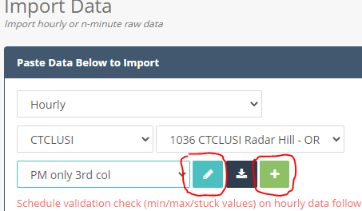

NOTE: if the drop-down list of monitors does not include the monitor you want to map, see Establishing Monitors Manually.

Here is an example data file with the corresponding import config in QREST:

date,time,pm10_MC

01/18/2020,20:00,37.68

01/18/2020,21:00,44.16

01/18/2020,22:00,29.52

01/18/2020,23:00,14.64

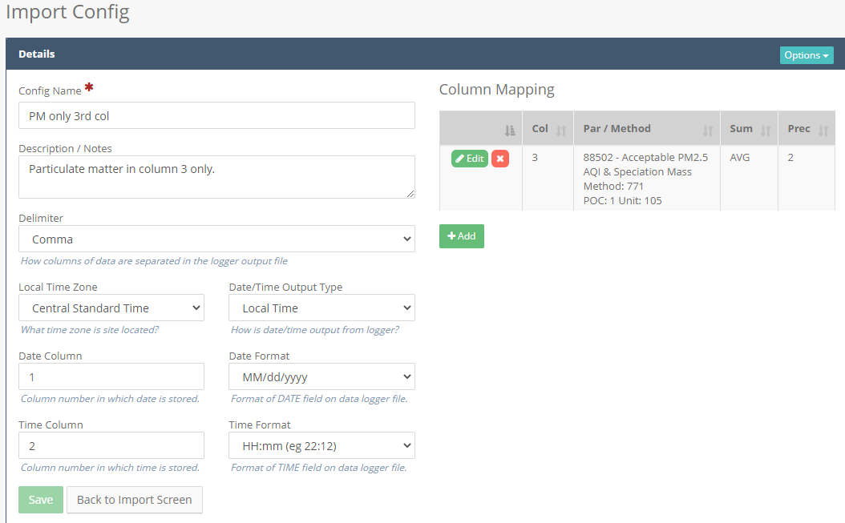

Complete the fields to set a logger configuration:

* **Config Name:** give your polling configuration a descriptive name. (A site may have seasonal or other polling configurations, and the Config Name will help distinguish different configurations.)
* **Delimiter:** How columns of data are separated in the logger output file.
* **Local Time Zone:** the time zone in which the site is located.
* **Date/Time Output Type:** identifies how data is output on the data logger, either in local standard time or UTC time.
* **Date Column:** Column number in which date is stored.
* **Date Format:** Format of DATE field on data logger file.
* **Time Column:** Column number in which time is stored.
* **Time Format:** Format of TIME field on data logger file. (If the time format is not in the drop-down list, please contact the TAMS QREST Admin.)

Click **Save**.

A message box in the upper right-hand side of the screen will indicate saved records in QREST.

Use the **Options** drop-down menu to delete this Import Config or download a File Template:

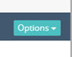

The **File Template** is an Excel file with the column headers corresponding to the Import Config, which can reference the parameters sequence in the data.

### 8.3.3 Importing Data

To import data, select the import type, agency/organization, site, and (if applicable) the import template. Then copy/paste your data into the textbox, **with no headers**, as shown here:

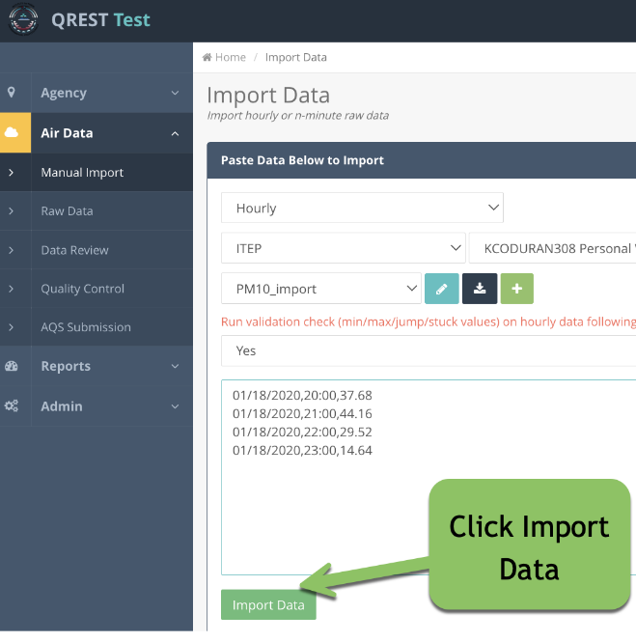

After pasting, click the **Import Data** button.

**QREST will then perform the following steps:**

1. **CREATE IMPORT RECORD:** Creates a unique ID for this import attempt and stores a copy of the block of data you are attempting to import. Sets the import status to **STARTED**.
2. **ESTIMATE IMPORT DURATION:** Determines if the import data is small enough to import immediately, or if too large, schedules it to run in a QREST background queue. If the import file is not large, QREST proceeds immediately to the next step.
3. **PARSE/VALIDATE/STAGE:** Parses and validates import data and writes to staging table.
   1. Updates import status to **VALIDATING.**
   2. This includes the following validations:
      1. Skips any blank rows or rows that do not have delimited data.
      2. Marks record as failed if date or time cannot be read.
      3. Calculates and stores both UTC and local time for record.
      4. If value is numeric, stores as numeric.
      5. If value is non-numeric, completes the following non-numeric handling:
         1. Strips out any asterisk (*) characters from non-numeric codes to allow Clients to import AQS QA codes, such as “6” for “QAPP Issue”. Clients can import this data as “*6” so QREST knows it should be imported as an AQS Code and not as a numeric value of 6.
         2. Non-numeric length greater than 5: fails validation (allowable codes cannot exceed 5 characters in length).
         3. Non-numeric and matches an AQS NULL Code: stores result as the AQS Null Code.
         4. Non-numeric and matches AQS QUAL Code: stores result as the AQS Qualifier Code.
         5. Stores the non-numeric as a Client-defined code.
      6. Marks any records as “duplicate” if a record already exists in QREST for that monitor and datetime.
   3. Updates import status to **VALIDATED.**
4. **PAUSES FOR CLIENT CONFIRMATION:**

A confirmation page opens to verify that QREST is importing the records how you want them imported, which is important if data are already in these records.

* **No validation errors:** If no validation errors are found, QREST will immediately proceed to Step 5.
* **Existing Data Found:** If existing data is already in QREST for the monitor and date/time, the import will pause and require you to confirm whether to proceed with the import. If you confirm, QREST will proceed with the following step and overwrite the old data with the new data:

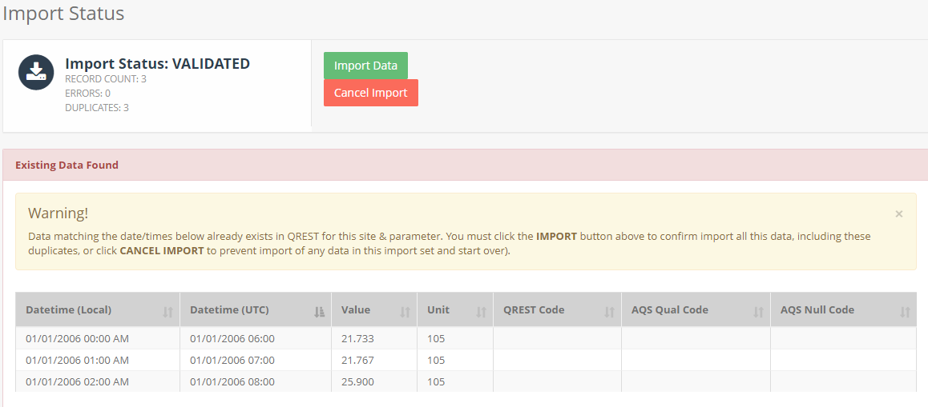

* **Validation Errors**: If validation errors are found, the import will stop. You will need to fix the source data file and re-attempt the import.

1. **COMPLETES FINAL IMPORT:**
   1. Updates import status to **IMPORTING.**
   2. Bulk-copies data from import staging table to either HOURLY or FIVE_MINUTE table, which may include data inserts or data updates on overwriting existing data.
   3. Updates import status to **IMPORTED.**
2. **PERFORM LEVEL 0 DATA VALIDATION (optional):** If you are importing hourly data and have indicated on the import screen to schedule a validation check (min/max/stuck values), then QREST will validate all imported data against the min/max/jump/stuck value alerts defined for that monitor. This may take time and the recently imported data may show as pending validation checks on the imported data in the Data Review screen.

### 8.3.4 Import History

Navigate to **Air Data > Manual Import**. Click on the **View Import History** button to view the history of all data imports you have completed.

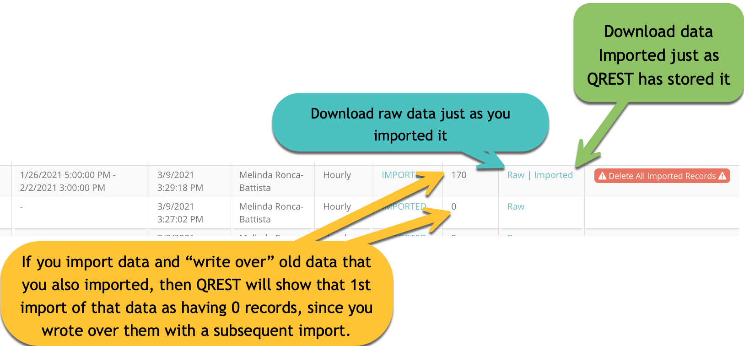

For each import, you can view the import type, import date, import status, and number of records in the import. If you click the Download button, an excel file with a table will open or download depending on your browser preferences, and you can see what was imported in every previous import.

In addition, you can delete all data corresponding to a particular import. This is useful if you perform a data import, notice a mistake, and wish to back out the imported data from QREST; keep in mind this **cannot** be undone.

**IMPORTANT:** the number of records indicates records **currently in QREST** that correspond with the import file. If data is imported then imported a second time, thus overwriting data in the first import, then the number of records tied to that original import will be zero.

## 8.4 Viewing Charts and Tables

### 8.4.1 Selecting Data to View

In the **Raw Data** and **Data Review** pages, you can zoom in/out of the charts, view and sort data in the tables and charts. However, the **Raw Data** screen is intended as a quick view of data, and the **Data Review** page is for editing flags, adding notes to individual or groups of records, and preparing the data for AQS submission.)

Example of Raw Date view:

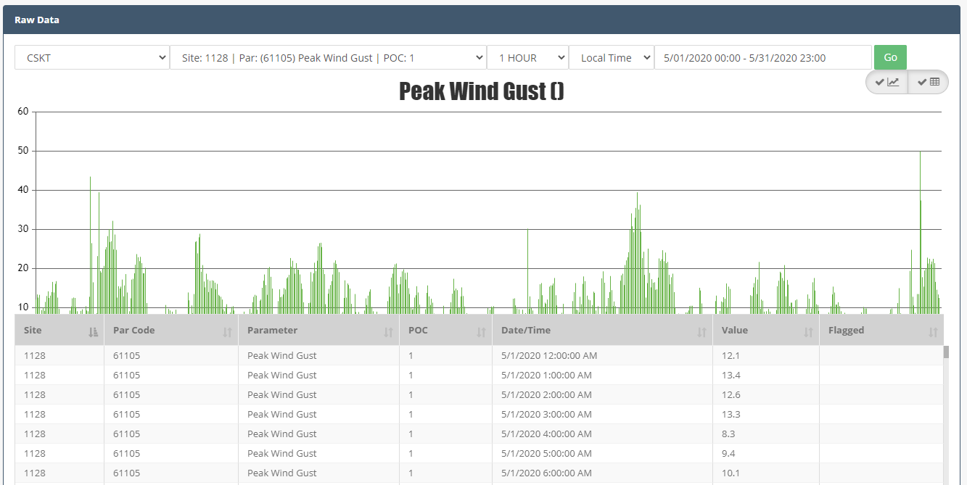

Navigate to **Air Data > Raw Data** to view Charts and Tables:

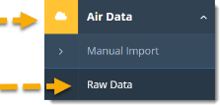

Select the **Agency**, **Parameter**, **time interval** (5-minute or hourly), and the time specified as either local or UTC.

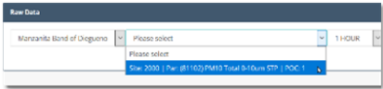

Click in the **datetime interval** box to open a selection list. Select *Yesterday, Last 7 Days, This Month,* or *Last Month* to populate the datetime interval field.

Select *Custom Range* from the selection list to open a calendar option:

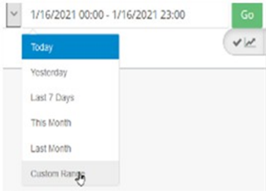

You can also type dates and times directly into the datetime interval box, or double-click to highlight and type over text (add a space between the year and time):

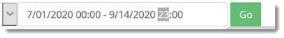

Click **Go** to generate the chart and table of the selected data.

### 8.4.2 Advanced Review Options

The typical data review assumes a review of hourly data for a 1-month duration, looking at a single parameter. In the Advanced Data Review, you can compare up to three parameters on stacked charts within the same time period. Advanced review options include (1) additional parameters, (2) n-minute data, and (3) a date range other than 1 month worth of data.

Navigate to

Select the **Agency/Organization**, the **Review Parameter**, any **Supporting Parameters**, the **Data Type**, and the **Date Range**.

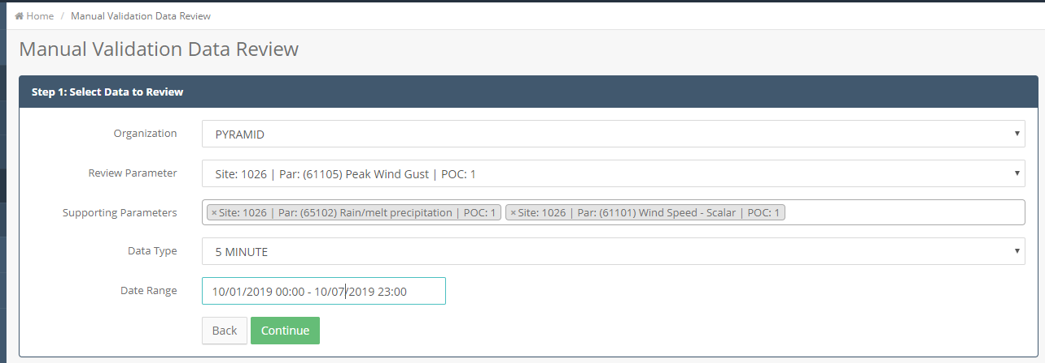

Click **Continue** to view the chart and table:

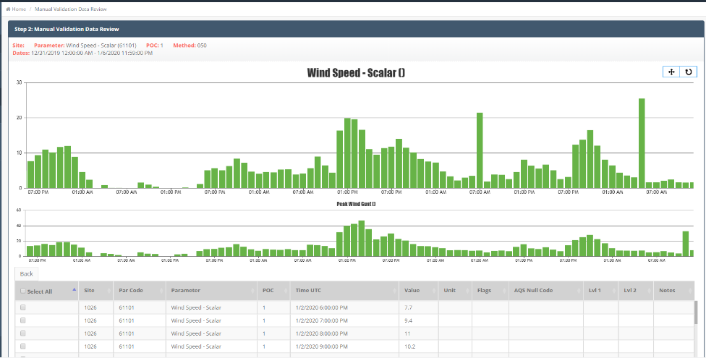

NOTE: the table under the stacked charts will present only the first parameter in the selection pane.

### 8.4.3 Charts

Color-coded charts help you quickly identify values that need further review:

* **Red bars** = values that are outside the min/max Level 0 criteria.
* **Gray bars** = "stuck" or identical contiguous values. They may also represent records that are incomplete or still calculating hourly averages.
* **Purple bars** = values that "jump" from one record to the next by more than your preset Level 0 criterion.

Click and drag the cursor to zoom in over the data set you want to see in more detail:

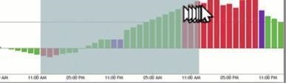

When you zoom in on a chart, a toolbar with three options displays in the upper-right:



* Click the **Pan** button (four-directional arrow icon) to slide the chart and view more of the data from your original selection.
* Click the **Reset** button (circular arrow) to reset the chart to its original datetime selection.
* Click the **Export** button (three horizontal lines) to print or save the chart.

### 8.4.4 Table Display

The table below the chart automatically adjusts to match the chart view when zoomed in on or panned over a data set. (This automatic adjustment does not occur in the *Data Review* feature, because the assumption is that data are being edited and zooming is done to look at detail in a larger dataset.)

**Different Viewing Formats --**

Note: None of these viewing options changes data in any way.

In either the **Raw Data** or **Data Review** page, the default view is the chart in the top pane of the screen and the data table in the bottom pane of the screen.

Click the **chart icon** to toggle the chart on or off:

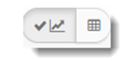

Click the **table icon** to toggle the table on or off:

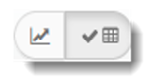

The **Flagged** column in the table will indicate Level 0 flags as a caution (yellow triangle) icon when a record (row) is undergoing L0 review, or if the hour is not complete yet. A corresponding gray column will appear in the chart.

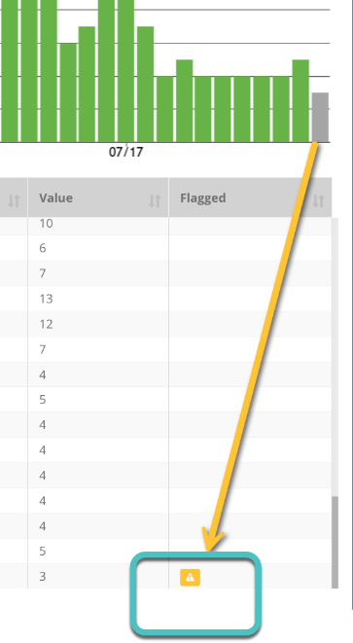

Once QREST completes the L0 review or the hour is complete, these indicators will disappear.

Click the **sort** icon (up/down arrows) in each column header to sort columns in the table:

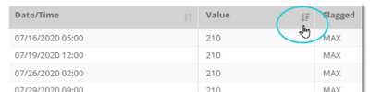

Once sorted, the arrow turns dark gray. This example is sorted by Value. Click the icon again to toggle min to max. Click the sort arrow in the Date/Time column to sort in sequential order from oldest to newest, then toggle again to sort from newest to oldest. Alpha characters in any column will sort differently than numeric values but repeat toggling will group rows together.

If you have the chart open in the top pane, it will not change if you sort values in the table. But, if you lasso a subset of values in the chart, the table will refresh to display only those values.

## 8.5 QREST Procedure for Data Review

QREST presents the default view for Data Review by month, but the formal data review process can occur at intervals that suit the Tribal Agency. Depending on program objectives, three or more individuals may review the data before it is finalized as *valid*. In other programs data may be managed, reviewed, validated, and reported by one individual.

However, **to use QREST's node to send data to AQS, both the Level 1 and Level 2 review must be completed**. QREST’s node can send any data set, even a few records, to AQS if both the Level 1 and Level 2 reviews are complete.

* **Level 1 Review** is conducted in QREST by the Site Operator or the Tribal Agency Admin.
* **Level 2 review** is conducted in QREST by the Tribal Agency Admin or the assigned QA Reviewer.

Because Tribal Agencies operate differently, QREST is flexible and allows a Tribal Admin to assign Level 1, Level 2, and QA reviewers as the same or different individual(s) and internal or external to their Organization. **Supplementary information for Level 1, Level 2, and QA Reviewer roles and procedures are presented in a supplementary document.**

It is important to note that almost all data polled and imported has some records that should not be used when calculating summary statistics or charts, because they represent routine instrument checks or error codes. For example, the inclusion of even one record with a –999 value will affect the overall average, and the charts will be unreadable if that value is included as part of the chart.

Charts and tables in QREST use all the selected records without AQS null codes, so until a set of data is reviewed, and any invalid records are assigned null value codes, the charts and tables may be misleading. After invalid records are assigned AQS null value codes, they will not be included in summary statistics and will show in charts as “missing” (highlighted pink):

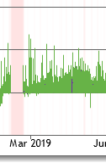

Navigate to **Data Review > Monthly Site Review Summary** to see an overview of the monthly data retrieval and review progress:

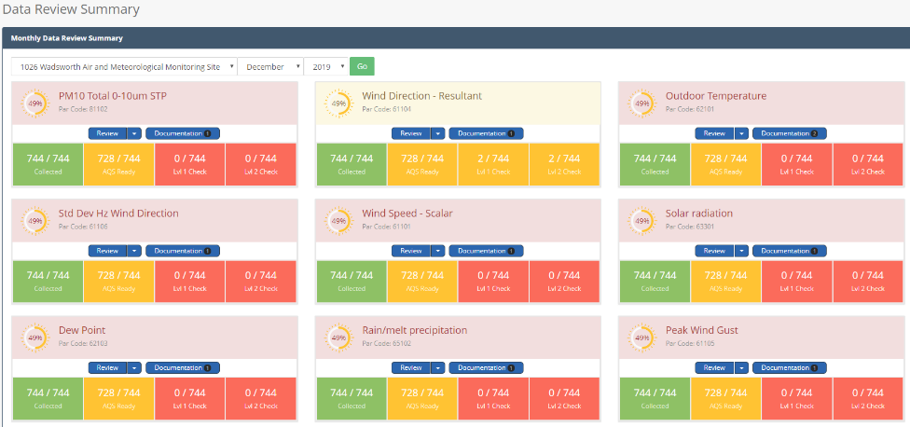

This panel lists all parameters monitored at the Site and indicates the overall completion percentage for the month for each parameter. The parameter is color-coded to display the progress for (1) data retrieval (2) AQS readiness (3) Level 1 validation, and (4) Level 2 validation. “AQS Ready” indicates that it has a value or a null code, and units. Data still must be checked as completed L1 and L2 review before the QREST can send it to AQS.

Navigate to **Advanced Review** to select the time interval and monitors for reviewing more than or less than one month of data:

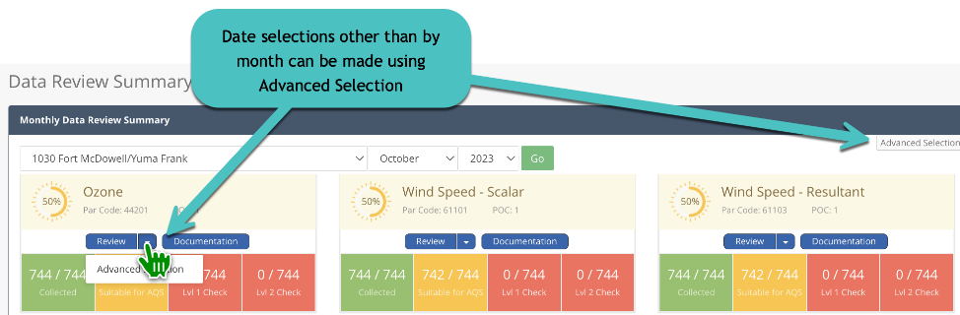

Select the data and click the **Review** button to review the hourly data for that parameter in a chart and table:

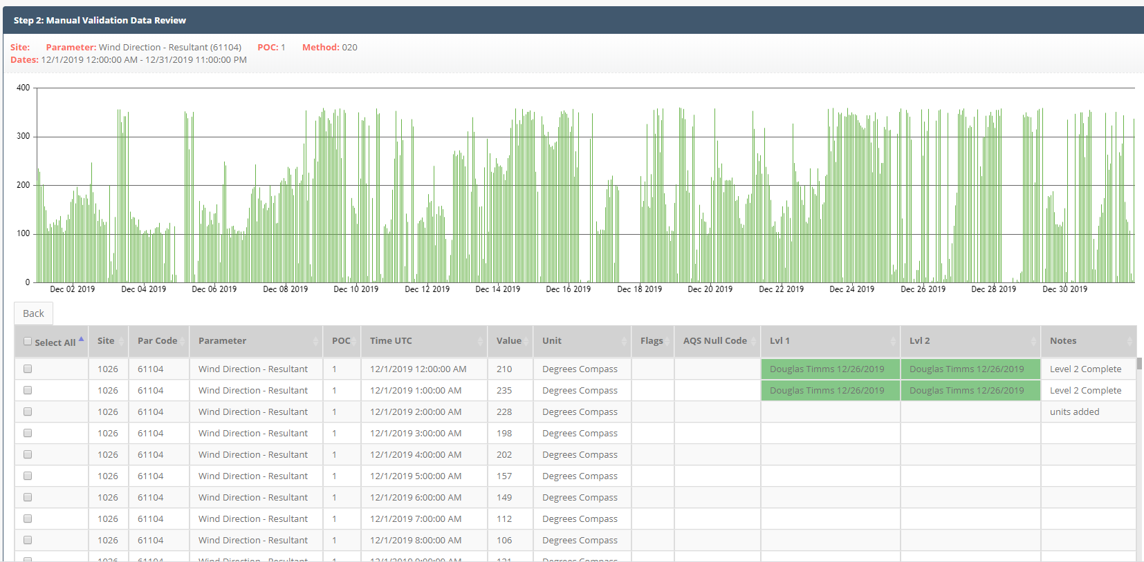

### 8.5.1 Adding/Editing AQS Null Codes, Notes, and Completing Level 1 and Level 2 Review

Tribal Agency Site Operators and Tribal Agency Admins can conduct a Level 1 Review, but Tribal Agency-assigned QA Reviewers can view notes, supporting documentation, and change AQS null codes and qualifiers (AQS flags). Level 2 Review can only be conducted by the Tribal Agency Admin and the Tribal Agency-assigned QA Reviewer.

Check the boxes for the records (rows) in the Select All column of the data table to edit, add a notation, or validate the data. The **Bulk Edit Selected** button will appear:

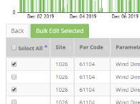

When comparing multiple monitors’ data in Advanced Review, the table under the charts will only show the data from the monitor that is being reviewed (the top monitor in the data selection pane):

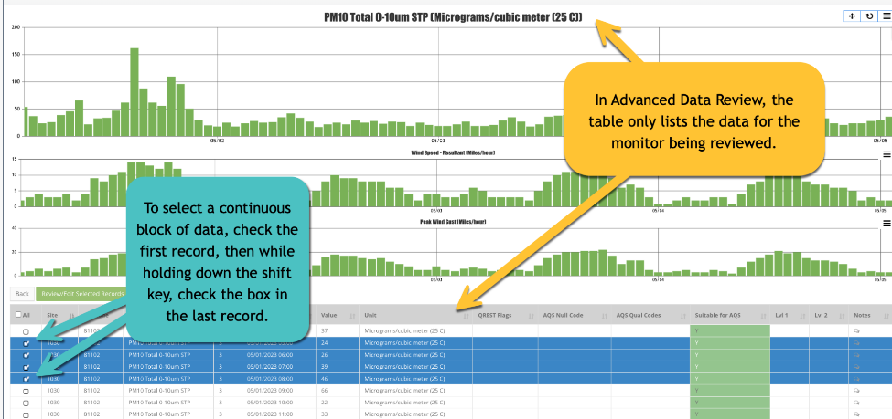

To select all the data displayed, click the **All** button in the first column:

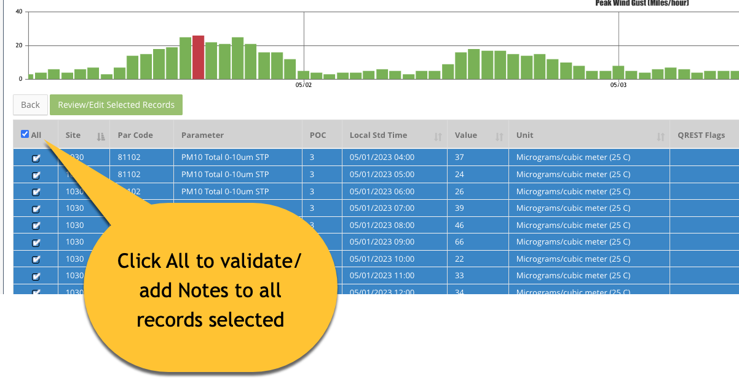

Click the **Review/Edit Selected Records** button:

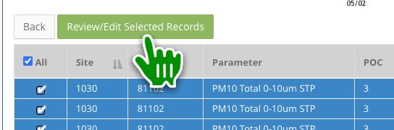

This displays the **Bulk Edit** pane:

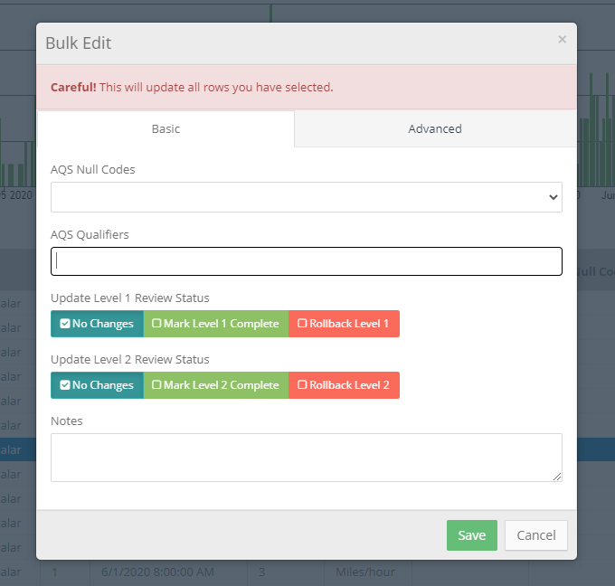

This consists of two tabs:

* **Basic Tab:**
  + Apply an AQS Null Qualifier Code to the selected data.
  + Apply one or more AQS Qualifier Codes to the selected data.
  + Perform Level 1 Validation (or rollback validation), for Tribal Agency Admins or Site Operators.
  + Perform Level 2 Validation (or rollback validation). This is only available to QA Reviewers or Admins.
  + Add notes (these are required whenever anything in a record is changed).
* **Advanced tab:**
  + Bulk-modify the value for the selected data.
  + Bulk-modify the unit code for the data. This is only accessible by QA Reviewers or Admins.
  + Apply a new QREST Flag.

## 8.6 Data Review Supporting Documentation

QREST Clients can upload and access documentation, including Clients assigned to a Tribal Agency as a Site Operator, Tribal Agency Admin, or QA Reviewer. This allows quick access to records needed to understand the decisions for data validity and invalidity. Additionally, Clients can associate documentation with specific sites or monitors. QREST securely stores files online and performs backups nightly.

Examples of documentation include:

* site logbook pages (includes initials, date, time, and info necessary to reconstruct processes and measured on the scanned pages),
* photos (includes date in filename) to document site visits,
* videos of up to 25 megabytes (Mb),
* Quality Assurance Project Plans (QAPPs),
* reference tables,
* audit reports, and
* other relevant files.

This Supporting Documentation feature is available from either the Site page or the Data Review page.

Navigate to **Air Data > Data Review**:

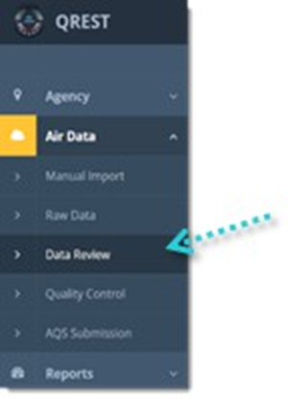

Select the **Site**, **Month**, and **Year** in the drop-down boxes and click **Go**.

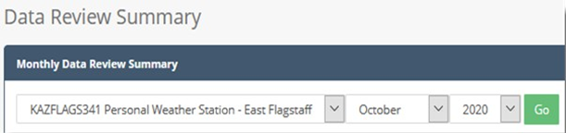

This opens a pane of all parameters and their status for the selected month Click the **Documentation** button to upload or view existing documents for each parameter:

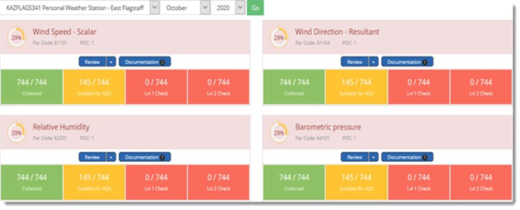

Click the **+Upload** button to upload documents that are applicable site-wide (left column) or to the parameter only (right column):

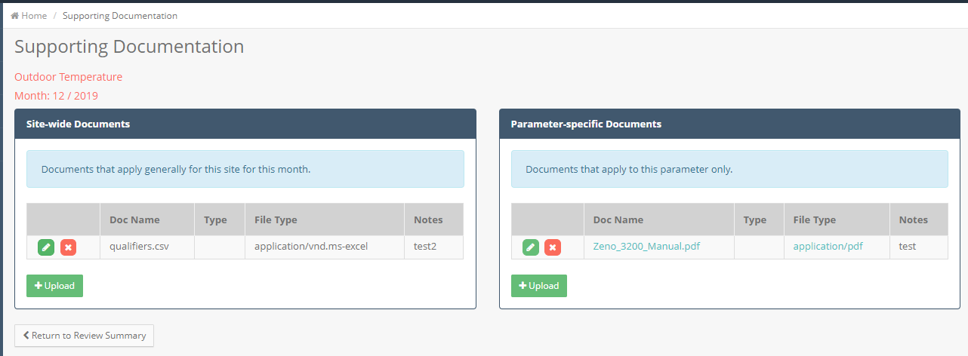

Click **Browse** and navigate to the file on your computer. Enter the **Start and End Dates** that the file applies to and an optional **Description**:

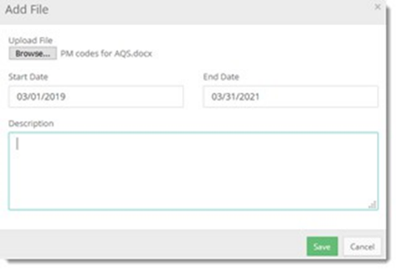

After uploading files, click **Save**. Click **Return to Review Summary**.

The documentation button will display the number of files uploaded:

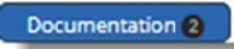

# Quality Control

Clients can enter information regarding a variety of quality control (QC) checks in QREST. QREST performs validation runs on these checks to determine if the data is valid according to EPA criteria. Clients can then use QREST to submit QC data to AQS.

## 9.1 Types of QC Checks

You can enter Quality Control (QC) data into QREST. Once in QREST, these results are available to a data reviewer to ensure that results are within limits, not trending in one direction, and conducted with equipment at specified frequencies. In addition, QREST can send QC data to AQS. (Note: NAAQS regulatory programs must report QC data to AQS.)

QREST reviews QC results of parameter data and presents the results as percentage differences. These percentages are the basis for estimates in the US EPA AQS AMP256 reports and are important to keep within the limits specified in a QAPP. QREST calculates these percentage differences for your tracking purposes and provides the node to AQS for QC data.

All QC types required for NAAQS regulatory data are available in QREST:

* **One-Point QC *for gaseous pollutants*:** The bi-weekly one-point QC check is required to be reported within the range of 0.005- 0.08 ppm for O3, SO2 and NO2 and 0.5- 5 ppm for CO. The QC check gas concentration selected within the prescribed range should be related to the monitoring objectives for the monitor. If monitoring at an NCore site or for trace level monitoring, the QC check concentration should be selected to represent the mean or median concentrations at the site. If the mean or median concentrations at trace gas sites are below the MDL of the instrument the Agency can select the lowest concentration in the prescribed range that can be practically achieved. If the mean or median concentrations at trace gas sites are above the prescribed range the Agency can select the highest concentration in the prescribed range. An additional QC check point is encouraged for those organizations that may have occasional high values or would like to confirm the monitors' linearity at the higher end of the operational range or around NAAQS concentrations. If monitoring for NAAQS decisions, the QC concentration can be selected at a higher concentration within the prescribed range but should also consider precision points around mean or median monitor concentrations. Due to the audit levels being expanded to allow for lower concentration audits to support NCore and trace-level work, a May 5, 2016, Technical Memo5 was posted on AMTIC in which EPA suggests the use of “dual” acceptance criteria for one-point QC checks that are performed at lower concentration ranges. The data is evaluated in the AQS AMP256 Report under “One Point Quality Control”.
  + O3: + 1.5 ppb difference or + 7 percent difference, whichever is greater (from 5-21.5 ppb, 1.5 is greater than 7%)
  + SO2: + 1.5 ppb difference or + 10 percent difference (from 5-15 ppb, 1.5 is greater than 10%)
  + NO2: + 1.5 ppb difference or + 15 percent difference (from 5-10 ppb, 1.5 is greater than 15%)
  + CO- NOTE: since the low end of CO one-point QC checks is 0.500 ppm, the absolute difference acceptance criteria that was developed for the annual PE (+ 0.03 ppm for concentrations <0.200ppm) will not be in effect.

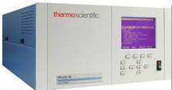

* **Annual Performance Evaluations (PE *for gaseous pollutants*):** the Annual PE includes ten audit levels for the gaseous pollutants of SO2, NO2, O3, or CO. The evaluation is made by challenging the monitor with audit gas standards of known concentration from at least three audit levels. One point must be within two to three times the method detection limit of the instruments within the PQAOs network, the second point will be less than or equal to the 99th percentile of the data at the site or the network of sites in the PQAO or the next highest audit concentration level. The third point can be around the primary NAAQS or the highest 3- year concentration at the site or the network of sites in the PQAO. An additional fourth level is encouraged for those agencies that would like to confirm the monitors' linearity at the higher end of the operational range. Due to the audit levels being expanded to allow for lower concentration audits to support NCore and trace-level work, a February 11, 2011, Technical Memo6 was posted on AMTIC in which EPA suggests the use of the following acceptance criteria for levels 1 and 2 audit ranges:
  + For O3, SO2, and NO2: + 1.5 ppb difference or + 15 percent difference, whichever is greater.
  + For CO: + 0.03 ppm difference or + 15 percent difference, whichever is greater.

For audit levels 3-10, the 15 percent difference acceptance criteria, currently in guidance, is acceptable. The data is evaluated in the AQS AMP256 Report under “Annual Performance Evaluation”.

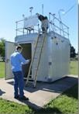

* **Zero Span *for gaseous pollutants*:**Zero and Span are two different measurements that are quality control checks. The zero check is a challenge of the instrument’s zero calibration conducted by introducing zero air into the analyzer and measuring the instrument response. The span check is a challenge of the upper limit of the analyzer’s calibration conducted by introducing a calibration gas (approximately 80% of the operating range) into the analyzer.
* **Flow Rate Verification *for PM pollutants*:**A one-point flow rate verification checks on automated and manual monitors used to measure PM10, PM10-2.5, PM2.5, and Pb (Pb-TSP and Pb-PM10). To perform the flow rate verification check, the monitor’s normal flow rate is checked using a certified flow rate transfer standard. This check is performed at different frequencies depending on the type of monitor being used. For manual method hi-vol samplers, flow rates must be verified on at least a **quarterly basis**. For manual method lo-vol samplers, flow rates must be verified on at least a **monthly basis**. For automated methods, flow rates must also be verified **monthly**.  
  Particulate monitors using automated methods usually sample continuously and report hourly average values as raw data to AQS. When this check is performed, if the hourly average raw data value is not available for reporting, then a null value and null data code is reported for that hour. The known flow rate of the transfer standard, and the measured (or indicated) value from the monitor, are recorded by the operator for entry into AQS for that monitor on that date. For manual monitors, the check is performed prior to or after sampling so there is no data loss.
* **Semi Annual Flow Rate Audit *for PM pollutants*:** The Semi-Annual Flow Rate Audits should be performed at least every 6 months on each monitor used to measure PM10, PM10-2.5, PM2.5 and Pb. To perform the audit, the monitor’s normal flow rate is checked using a certified flow rate transfer standard which is different from the one used for calibrating the monitor. The auditing Agency conducting the Semi-Annual Flow Rate Audit may be the PQAO or may be an independent Agency. In any event, the assessment should be conducted by someone other than the routine site operator.  
  Particulate monitors using automated methods usually sample continuously and report hourly average values as raw data to AQS. When this audit is performed, the hourly average raw data value may not be available for reporting, in which case a null value and null data code are reported for that hour. The flow standard value (known flow rate of the transfer standard), and the monitor value (response value indicated by monitor) are recorded by the operator for entry into AQS for the monitor being assessed, for that date. For manual monitors, the assessment can be performed before or after sampling, so there is no data loss.

***Semi Annual Flow Rate Audit:***

* performed at least every 6 months on each monitor used to measure PM10, PM10-2.5, PM2.5 and Pb.
* To perform the audit, the monitor’s normal flow rate is checked using a certified flow rate transfer standard (which should be a different standard than the one used for calibrating the monitor).
* The auditing Agency conducting the Semi-Annual Flow Rate Audit, according to CFR, * may be the PQAO, or an independent Agency. In any event, the assessment should be conducted by other than the routine Site Operator.
* Like the monthly flow rate check, the percent difference between the flow standard's value and the monitor value can be calculated by QREST and subsequently sent to AQS on the tribal Agency's schedule.

*Check the exact, legal QC requirements for the parameter at <https://www.ecfr.gov/current/title-40/chapter-I/subchapter-C/part-58>.

## 9.2 QC Data Entry

To create a Quality Control record in QREST to store the results of QC checks that at some point can be sent to AQS, navigate to **Air Data > Quality Control:**

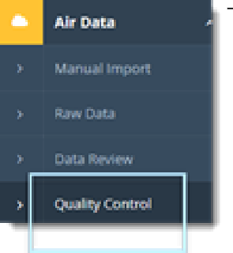

If there are no QC checks entered, you will see a blank table:

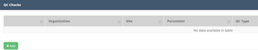

Existing QC checks display as a list. You can sort columns with gray arrows in the header:

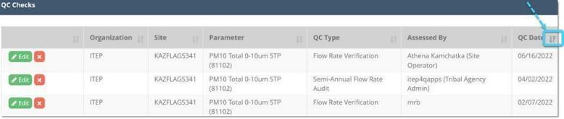

Click the **Add** button to open a blank pane where you can enter the results of the QC Check:



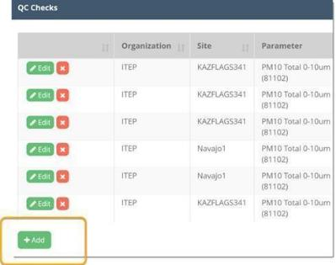

Select the **Assessment Type, Assessment Date,** and **Select a Monitor**. These fields are required (as they are in the AQS QC file):

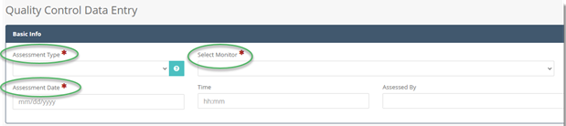

Optional: Enter the time and individual that completed the assessment.

Click **Save. NOTE that you must click Save for the next panel of the QC data entry form to open.**

QREST will create one or more blank rows to enter the assessment details:

* **10 rows for Annual Performance Evaluation results (gaseous monitors)**
* **1 row for all other assessment types, such as flow rate checks for PM monitors**

Here is an example of 10 blank rows created for an Annual Performance Evaluation:

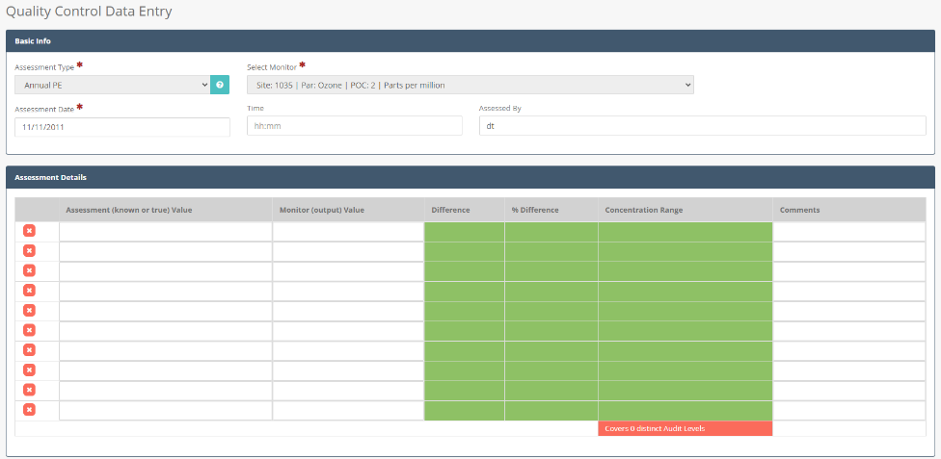

For each row, enter in the **Assessment (known or true) Value** and the **Monitor (output) Value**. Click **Save**.

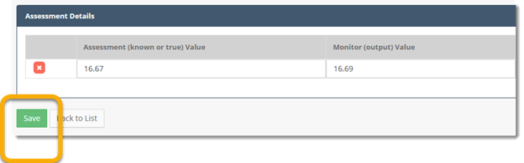

QREST will evaluate the values and shade them *green* if they meet the US EPA’s limits, such as within 4.1% for PM2.5 continuous monitor flow rate checks, or *red* if they do not meet the requirements:

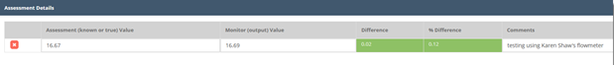

The automated checks done by QREST are described below.

## 9.3 PM QC Checks

For particulate matter (PM) monitoring, there is no standard cylinder of PM to compare your analyzer's readings with. Instead, the determining parameter for PM monitoring is *flow rate*.

When you enter values for your flow rate check, check the units in the right-hand pane that opens. Select the **Flow Rate Units** for your transfer standard and your analyzer:

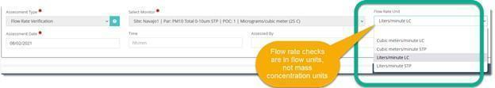

If you edit data or add new rows for a multi-point check, QREST blurs existing values while new values recalculate:

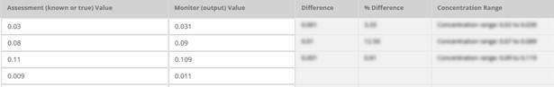

Click **Save** after you edit or enter values for QREST to calculate the **Difference, Percent Difference,** and **Concentration Range** (for gaseous pollutants).

A table will display the calculated values and indicate the number of AQS-required concentration "bins" that have been filled:

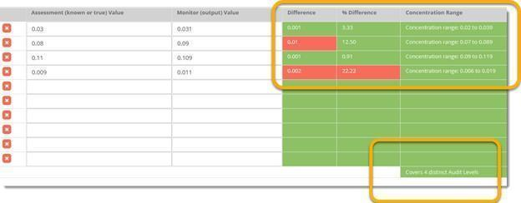

## 9.4 QREST’s automated checks on QC Data Entered for NAAQS Parameters

QREST checks the information and values you entered to ensure they satisfy US EPA requirements for successful loading to AQS.

* **Annual Performance Evaluation:** 
  + **Distinct Concentration Range Check:** Assessments must cover 3 of the 10 concentration ranges defined by EPA.
  + **Percentage Difference Check:** 
    - Sulfur Dioxide (42401, 42406): must be less than 15% difference
  + **Concentration Difference Check:** 
    - Sulfur Dioxide (42401, 42406): must be less than 1.5 ppb
* **1-Point QC:** 
  + **Concentration Range Check:** 
    - Sulfur Dioxide (42401, 42406): concentration must be between 5 – 80 ppb
    - Ozone (44201): concentration must be between 5 – 80 ppb
  + **Percentage Difference Check:** 
    - Sulfur Dioxide (42401, 42406): must be less than 10% difference
    - Ozone (44201): must be less than 7% difference
  + **Concentration Difference Check:** 
    - Sulfur Dioxide (42401, 42406): must be less than 1.5 ppb
    - Ozone (44201): must be less than 1.5 ppb
* **Flow Rate Verification & Semi-Annual Flow Rate Audit:** 
  + **Percentage Difference Check:** 
    - PM 2.5 (81104, 88101, 88500, 88501, 88502): must be less than 4.1% difference
    - PM 10 (81102, 85101): must be less than 7.1% difference

## 9.5 AQS QC Data Submission

After QC data is completely entered, click the **Send to AQS** button to initiate the AQS submission process. This will allow you to select AQS file generation options, such as data format and action code.

Navigate to **Air Data > Quality Control.** This lists QC checks entered in QREST. Click **Edit** to open the page with the QC Check Data:



If the data are correct, click **Send to AQS**:

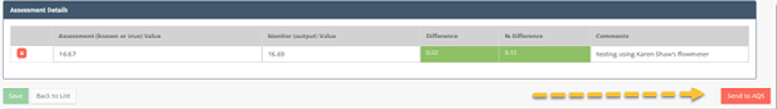

The AQS transmission will also prompt an email from AQS to you about the file posting status.

Click the **Generate File** button to generate the AQS file. The AQS submission tracker page will display:

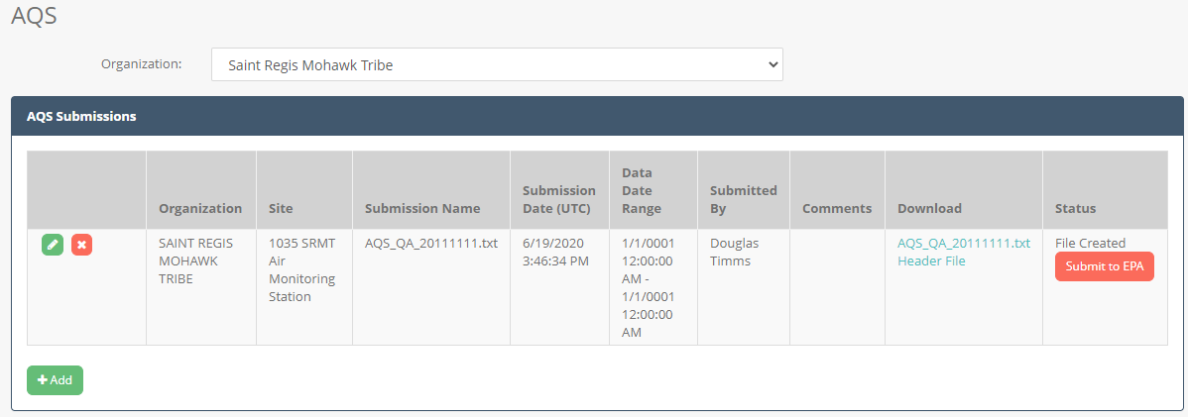

The **Get Status** button will eventually display the file as Completed in the **Status** column:

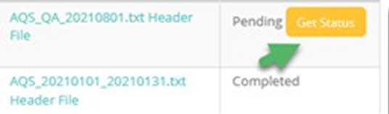

Click the links in the **Download** column to view the generated file. QREST stores two files related to the AQS submission:

* Text file containing only the AQS data.
* “Header” file which is a zip package containing the AQS data file wrapped in an Exchange Network header XML file. This is the package that is sent to EPA’s Exchange Network Node.

# AQS “Raw” Data Submission

The Air Quality Subsystem (AQS) is a database maintained by the US EPA. AQS stores and makes available air data records, including air pollutants, met data, airborne radioactive materials data, hazardous air pollutants (HAPs), and heavy metals. There are almost ten thousand different parameters, many with multiple units and collection times, which can be uploaded into AQS. Note that the US EPA uses the term “raw” data to refer to hourly concentration results. However, the final data in AQS should be validated by the Tribal Agency. QREST’s node can load, change, or delete data in AQS.

## 10.1 Overview and Initial Configuration of AQS in QREST

Ideally, a Tribal Agency should already have their site, monitors, method, and POC codes set up in AQS. That way, these codes can be imported directly into QREST, and the Client is assured that exact codes are in both AQS and QREST. Once this is set up, QREST’s node can send data directly to AQS.

If you load data "manually" to AQS without a node, you must first log into the EPA's Exchange Network Services Center (ENSC) at <https://enservices.epa.gov/login.aspx,> and then into AQS. However, you can use QREST to generate AQS submission files and submit them directly from QREST to AQS via the Exchange Network. To make an AQS submission of QC data, please refer to the Quality Control section.

## 10.2 AQS Requirements

1. *Data must be "Suitable for AQS"* – the records have either a numeric value or an AQS null code, and units assigned as shown in the tables.
2. *Data have completed L1 and L2 Reviews* – routine hourly parameter data must be both Level 1 and Level 2 reviewed before it can be sent to AQS. The Checks appear as green boxes in the Data Summary pane:

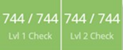

If you select a set of incompletely reviewed data, QREST’s AQS feature will direct you to edit, complete the review, and then generate the file to send to AQS.

1. *Data must be complete* – there are no gaps of missing hours in the dataset. If there are “LOST” records, QREST provides the opportunity to fill in missing records. Data can be sent in any increments (hour, week, or other intervals). Previously submitted data will not be overwritten in AQS because AQS will not accept duplicate records. However, if you want to replace previously submitted data in AQS or delete it altogether, QREST can send data to AQS that does this, by selecting Update or Delete in the type of AQS file you ask QREST to generate.
2. *Data must have units* – although QREST will send data without assigned units, AQS will not accept it. You can assign units to the **Monitor Edit** page.

QREST's prompts will guide you through the AQS submittal and generate and send three filetypes:

* Insert files - uploads new "inserted" data to AQS
* Update files - corrects existing data in AQS
* Delete files - deletes records in AQS

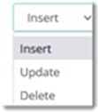

## 10.3 Initial QREST Configuration Required Before Making AQS Submissions Through QREST

To make an AQS submission, AQS must be set up so that it will accept data upload via QREST. These configuration steps in both AQS and QREST only need to be completed once.

**AQS User Account:** The Client must have an EPA AQS account with Screening Group access. The Client must contact EPA’s AQS program at <https://www.epa.gov/aqs/aqs-user-registration> to obtain an AQS account. It is not possible to load data into AQS without an AQS account connected to the Tribal Agency because QREST needs that to send data to the correct site.

**Identify Your Screening Group:** It is important that the exact spelling of your AQS Screening Group is entered into QREST, and sometimes the Screening Group has unusual or abbreviated Tribal Agency names.

Log into AQS with your account credentials to determine your Screening Group. As of 2024, the login steps include:

* <https://www.epa.gov/aqs>, and click the blue AQS button, which will prompt your computer to download a tiny javascript file. It may be that your work computer or the browser you normally use need to be configured to allow this, which is necessary to access AQS. This sometimes causes problems for Agencies with tight IT restrictions, but many grant work plans require data to sent to AQS.
* Double click to run the javascript file, which prompts the user to go to
* <https://login.gov/>, and new users must establish login credentials to login.gov or existing users log in, then
* After logging in, in the user is redirected to the AQS interface.

(Note: the email that AQS has for your account will receive notifications about the status of data submittal.) After logging in, AQS will ask if you are a **Read-Only Client** or have **Screening Group Access**:

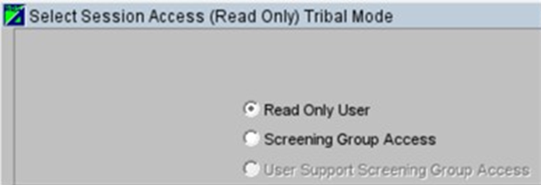

Select **Screening Group Access** to display the groups you are associated with:

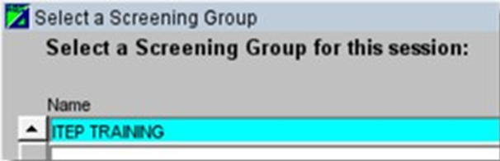

Copy or save the exact spelling and format of the Screening Group (case size, etc.). You will enter the text into QREST to send data to your AQS site, described in the procedure below.

### 10.3.1 AQS Authorization to use the Exchange Network Account

Whether the Tribal Client uses the default CDX account in QREST or uses their own, AQS must be configured to accept data from this CDX account. The Tribal Client can use their own Exchange Network account or the default built-in CDX account. To create an Exchange Network account, contact the EPA Help Desk at [nodehelpdesk@epacdx.net](mailto:nodehelpdesk@epacdx.net). It is not necessary to create a new CDX account, however, but either way, AQS needs to be set up to receive data via the CDX account. This requires logging in to AQS at least once.

**In AQS:**

**Authorize the Exchange Network Account:** Log into AQS using the AQS account you’ve chosen. Navigate to **Admin > Security** from the header:

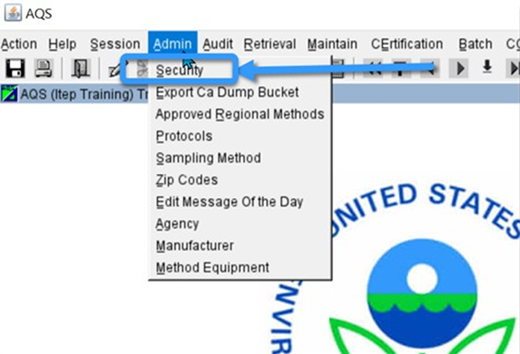

The AQS Security page will open. Leave the information as is (unless it is inaccurate) and **replace the EN Account with the EN account you want to use:**

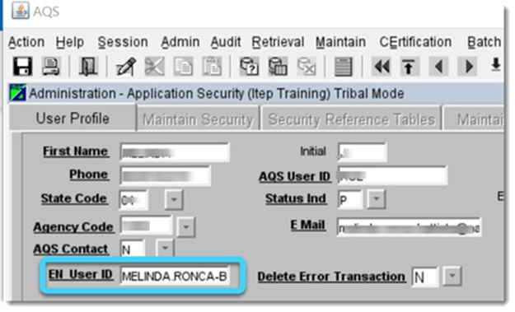

Click **Save**. Enter the EN account you decided to use from above. To use QREST’s EN account, log into AQS using your Tribal Agency credentials and type in [MELINDA.RONCA-BATTISTA@NAU.EDU](mailto:MELINDA.RONCA-BATTISTA@NAU.EDU) into the **EN User ID** field.

**In QREST:**

**Configure QREST** with credentials from above. Navigate to **Air Data > AQS Submission** in QREST. Click the **Add** button:

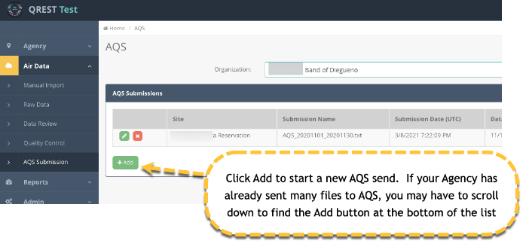

Select the Site from the drop-down list. The **Submission Accounts** box lists credentials QREST will use to complete the AQS submission. Click **Change** if this is the first time you are sending data to AQS, or to change the credentials:

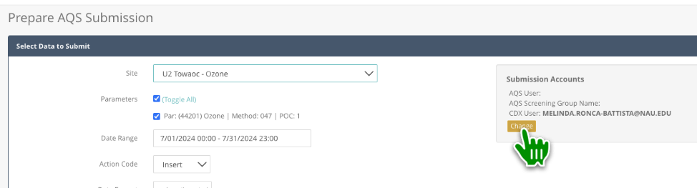

After clicking Change, the **AQS Submission Accounts** page will display:

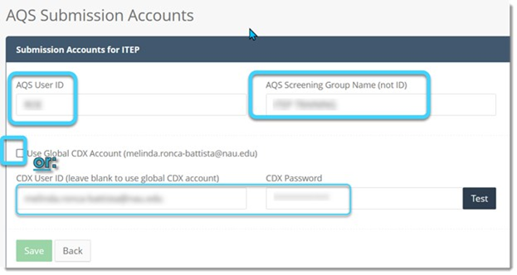

Enter the following:

* **AQS User ID:** The AQS user ID, assigned by EPA and associated with this AQS Screening Group.
* **AQS Screening Group Name:** The screening group (Agency) name in AQS. This should match exactly the screening group name in AQS.
* **CDX User ID:** The EN User ID configured in AQS as authorized to send data. You can choose to leave this blank and let QREST use its default CDX account to make submissions, but AQS still needs to be configured with that account.
* **CDX Password:** The password for the CDX (i.e., Exchange Network) account, which for the default CDX account leave blank. If you have configured AQS to receive data through the Tribal Client’s CDX account, then enter the password associated with that CDX account.

## 10.4 Making an AQS Submission

Navigate to **Air Data > AQS Submission** to submit hourly parameter data (AQS calls it raw data). You will see a history of all AQS submissions (both pending and completed) made through QREST:

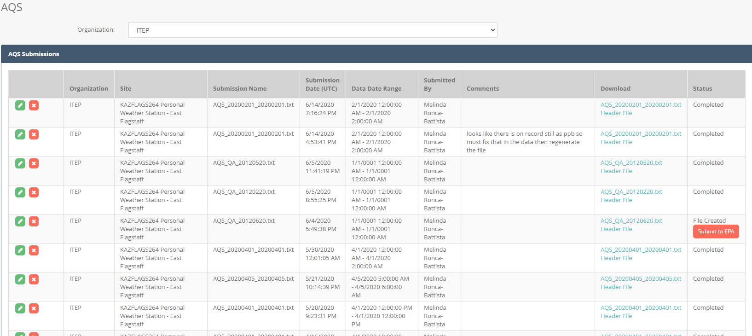

Click the **Add** button at the bottom to create a new AQS submission package:

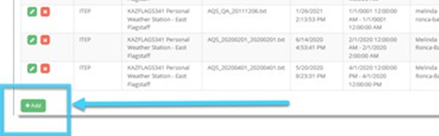

Check the **boxes** for the parameters you want to send. Click inside the **Date Range** box to open the datetime selection box:

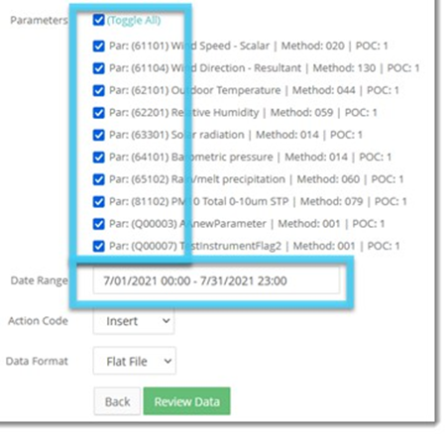

Choose the **start and end date/times** for the data and click the **Apply** button.

Select the **Action Code** and **Data Format**.

Click the **Review Data** button to display the **Data Review Summary**:

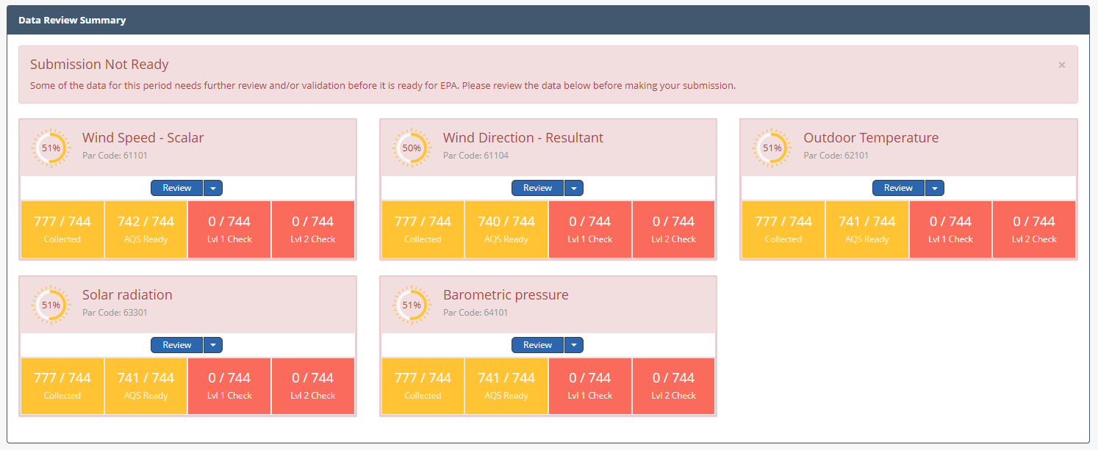

Each parameter box includes summaries for:

* **Collected:** Number of hourly records collected.
* **AQS Ready:** the values are either numeric, or if not numeric have an AQS Null Qualifier applied.
* **Lvl 1 Check:** Level 1 validation review has been performed.
* **Lvl 2 Check:** Level 2 validation review has been performed.

To make an AQS submission, data in the selected date range must be AQS Ready and have Level 1 and Level 2 validation performed. If the data selected does not pass validation checks, the following message will appear:



If all data matching the selection criteria is AQS ready with completed Level 1 and Level 2 validation, the **Generate File** button willappear:

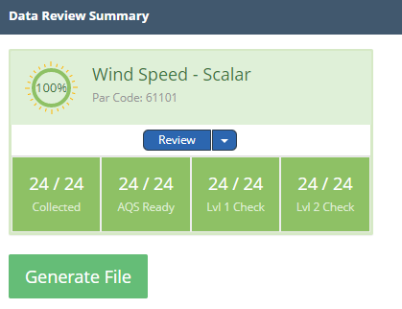

Click **Generate File** if your data is ready for AQS submission. This opens the panel with AQS submissions (both pending and completed). The most recent is listed at the top:

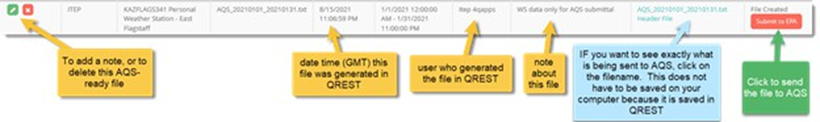

Click the **Submit to EPA** button if you’d like to send to EPA AQS or see the AQS Submission Statuses for more information.

### 10.4.1 AQS Submission Statuses

The AQS Submission status will display in the **Status** column as one of the following:

* File Created
* Submitted-Processing or Processing or Pending
* Failed (with no validation response file yet)
* Completed (with validation response file retrieved from EPA)

**Status = File Created:**

Initially, QREST generates the file but does not send it. Review the file by clicking the file link in the Download column or continue the submission by clicking the **Submit to EPA** button.

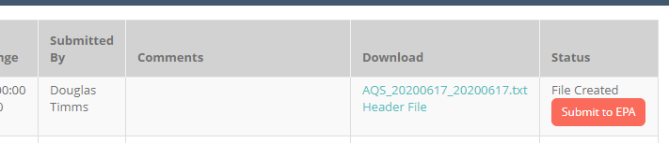

**Status = Submitted-Processing or Processing or Pending**

After the file is submitted, the status will initially be Submitted-Processing. Click the **Get Status** button to view the latest status in EPA processing. You may need to wait several minutes for the status to update.

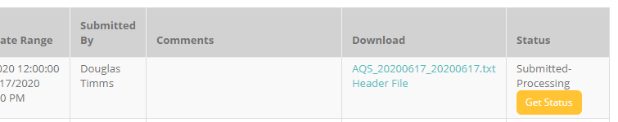

**Status = Failed**

If the status updates to Failed, click the **Validation Errors** link to see more details about why the submission failed.



**Status = Completed**

If the submission passed, the status updates to Completed. This indicates that the submission was successful.

## 10.5 Troubleshooting AQS Submission Problems

Click the **Validation Errors** link in the Status column if the AQS submission ***Failed*** to see more details. If the Validation Errors are unclear or blank, log into EPA’s EN Services Center. It may display a more detailed error message than QREST can download. This will only provide information on the AQS submittal if the data was sent using your own EN credentials, rather than the QREST Admin's credentials.

The URLS for the EN Services Center are:

* **Production:** <https://enservices.epa.gov/login.aspx>
* **Test:** <https://enservicestest.epacdxnode.net/Login.aspx>

Log in at <https://enservices.epa.gov/login.aspx> with **your EN (CDX) credentials.** After logging in, navigate to **My Services Center**:

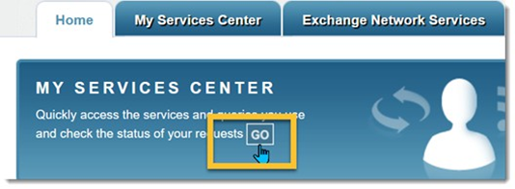

You will see a list of submittals with information about each. This information is repeated in 4 emails that are sent to the AQS user ID, and include:

**AQS Email Information**

The email from AQS to the Client in QREST will include information and links to a file with records that did not post. It is important to review the information in the email, even if the submission status in QREST is *Completed*. Even with a Completed status, some records might not have been posted in AQS. Even with a Completed status, some records might not have posted in AQS.

**Statistical and Critical Review Issues**

This message type informs you of unusual values in the dataset. The email will list the number of records that showed unusual values, relative to all the data that has been previously uploaded to this site/monitor in AQS. Often, this means that values are increasing and there is nothing wrong with your data. Click the link to go to an explanation page.

**Records that Failed to Load**

This message type informs you there was an overlap in this dataset with records that already existed in AQS. If any records did not load all the way through to *Post* in AQS, there will be a link in the email listing the records and explaining why.

**Records posted**

This message type indicates that the records you sent successfully posted.

See videos on to correct data in AQS, provided by the TAMS Center at <http://bit.ly/AQS_fastrack>.

# Reports

This section describes how to export various categories of data, codes, and information about your site, monitor, Level 0 criteria, and polling configurations.

## 11.1 Data Export Reports

Navigate to **Reports > Export Data**.

Select the data you want to export. If you only want measurement data from one monitor, select the Monitor, and 5-minute (if available) or hourly data. To export measurement data (Air Data), first select the Agency.

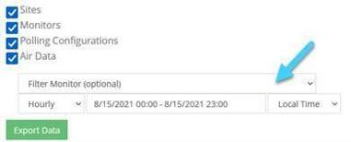

Click **Export Data** and open the downloaded file:

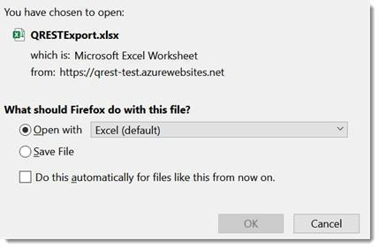

Sites, Monitors, Polling Configs, and Data will export in different Sheets in the same Excel file.

Your computer opens the file as an Excel Table, which provides tools for sorting data if the the checkbox in Excel’s table tools for header row is checked. To convert the excel table to an excel range, click on a **cell** within the table to change any of the tabs to an Excel Range. Click **Table Design**, **Convert to Range**:

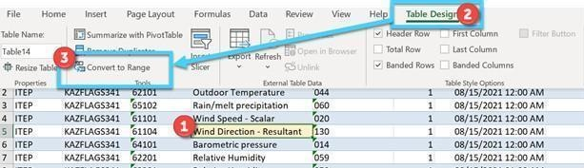

## 11.2 Daily Hourly Data Report

If a Tribal Agency Admin has set their site in QREST to be visible through the QREST map screen, as shown below, their parameter data will be viewable in the form of Reports.

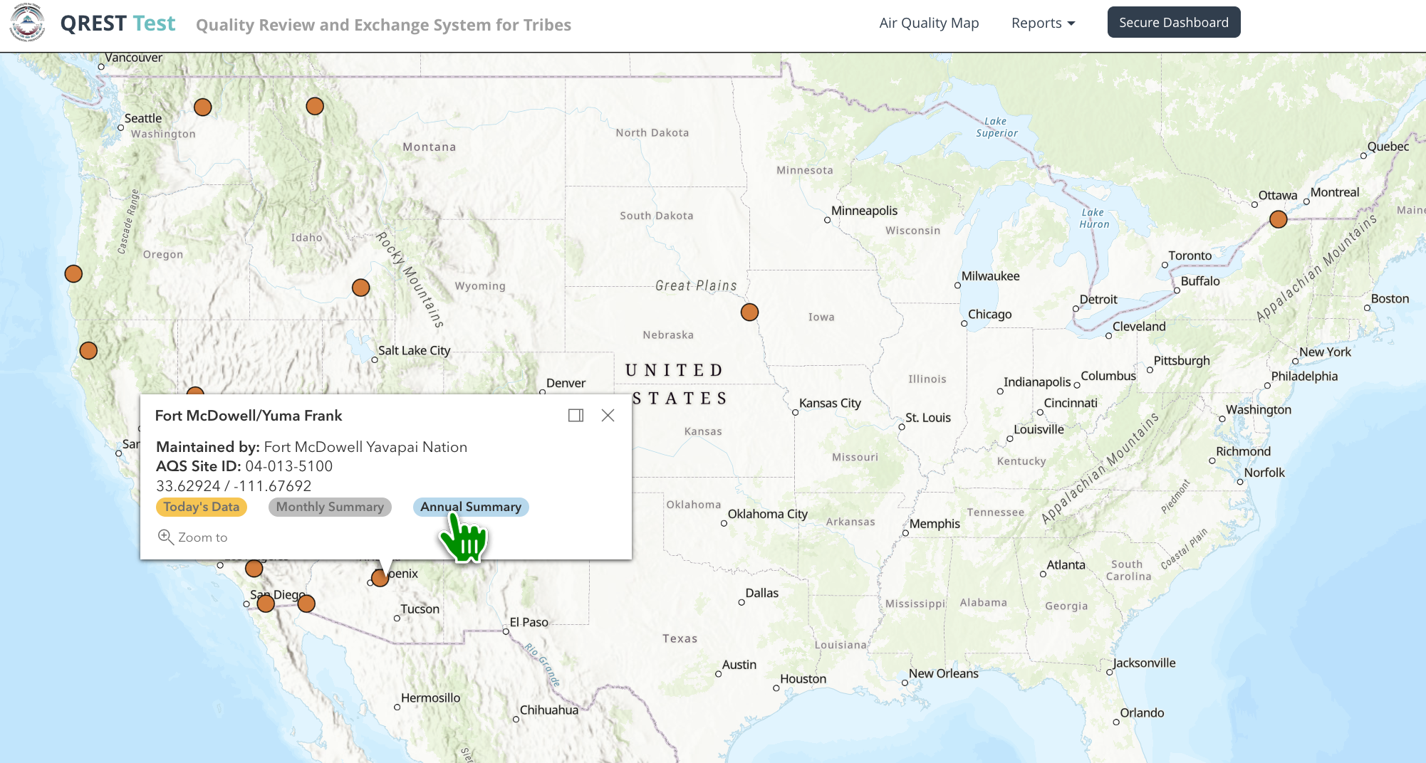

Some reports are only available from the Public page, including a *Daily Hourly Data Report* that displays hourly data for the current data at a particular site. Clients can select different sites or dates to view from the drop-down lists. The highest value for each parameter will be highlighted in red.

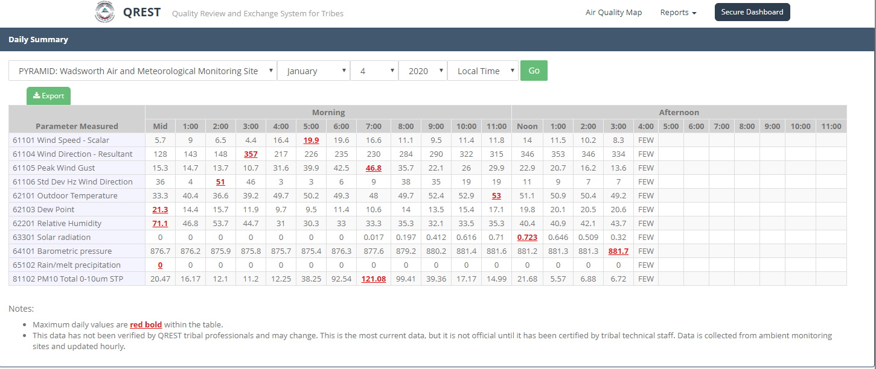

The **Export** button exports to Excel.

## 11.3 Monthly Hourly Data (Public map view)

The *Monthly Hourly Data Report* allows Clients to view hourly values in a month for a particular parameter and site. Clients can select different sites, parameters, or months to view from the drop-down lists. This format is sometimes called the single parameter grid format, in which data for only one parameter is presented in 24 columns for each hour, and every row is a new date in the month. The highest daily value for each parameter will be highlighted in red.

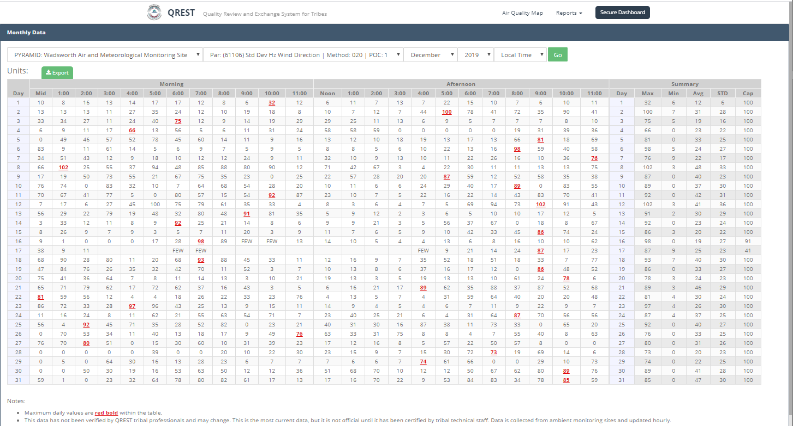

The **Export** button exports to Excel.

## 11.4 Annual Hourly Data (Public map view)

The *Annual Hourly Data Report* allows Clients to view hourly values in a calendar year for a particular parameter and site. Clients can select different sites, parameters, or year to view from the drop-down lists. The highest daily value for each parameter will be highlighted in red.

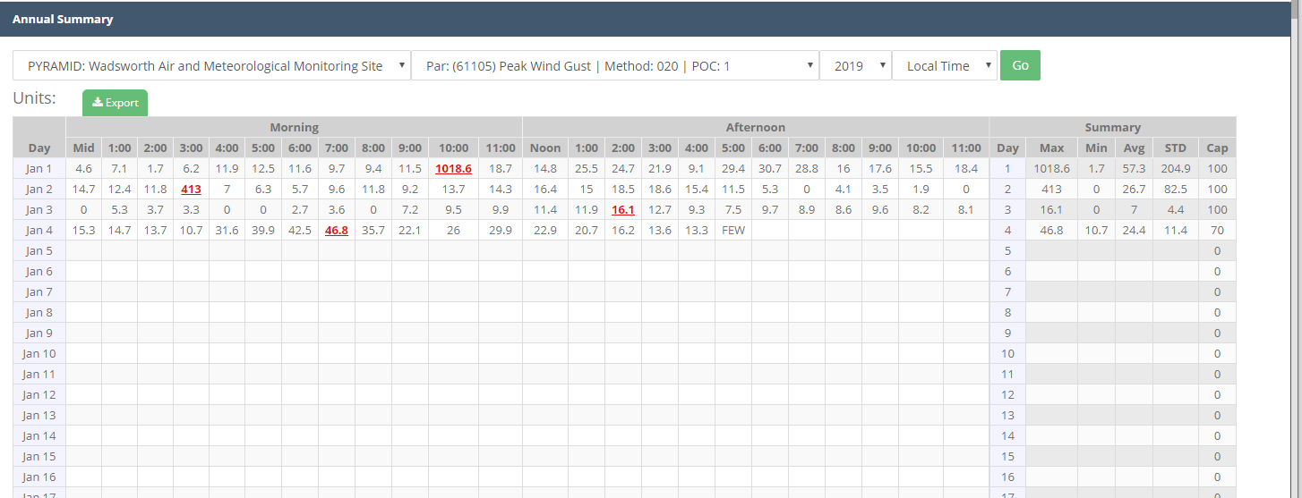

The **Export** button exports to Excel.

## 11.5 Monthly Statistics (Box and Whisker Charts)

**Monthly Statistics** displays a summary statistics table and a longitudinal box and whisker chart. The example below shows outdoor temperature at the Fort McDowell Yavapai Nation for a full 24 months:

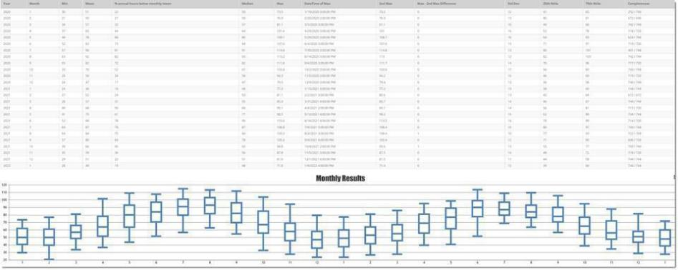

All records that are not assigned an AQS null code are included in Monthly Statistics. This means error code values are included, resulting in inaccurate statistics and charts. The table displays values in the Max column, but other invalidated data might not be obvious. A few hours of error code values such as -999 will affect summary statistics and charts, since QREST will include those -999 values until they are assigned null value codes. Because of this, Monthly Stats should not be used as final until all data is validated.

### 11.5.1 Generate a box and whisker chart

Navigate to **Reports > Monthly Stats**.

Select a **Site**, **Monitor**, and the **month/year start and end dates** of the interval. Click **Go**:

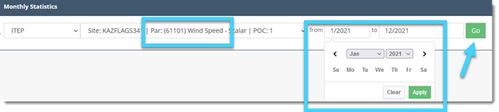

A pane will display the summary stats table and box and whisker chart:

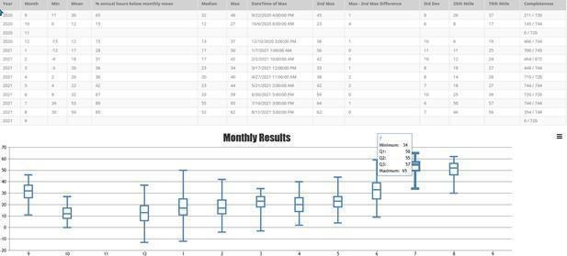

Click the **Export** button (three horizontal bars) to export the table and/or chart:

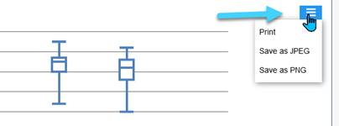

For more information on these types of charts, see:

* [https://www.epa.gov/sites/default/files/2016-09/documents/boxplots_companion- generic_v2_9_9_16.pdf](https://www.epa.gov/sites/default/files/2016-09/documents/boxplots_companion-%20generic_v2_9_9_16.pdf)
* [https://www.statisticshowto.com/probability-and-statistics/descriptive-statistics/box- plot/](https://www.statisticshowto.com/probability-and-statistics/descriptive-statistics/box-%20plot/)

# Public Website

## 12.1 Public Map

A public map shows all sites that are configured in QREST as showing data on the public page. If you want a site to be shown on the public QREST page, check this box in the Site Edit panel:

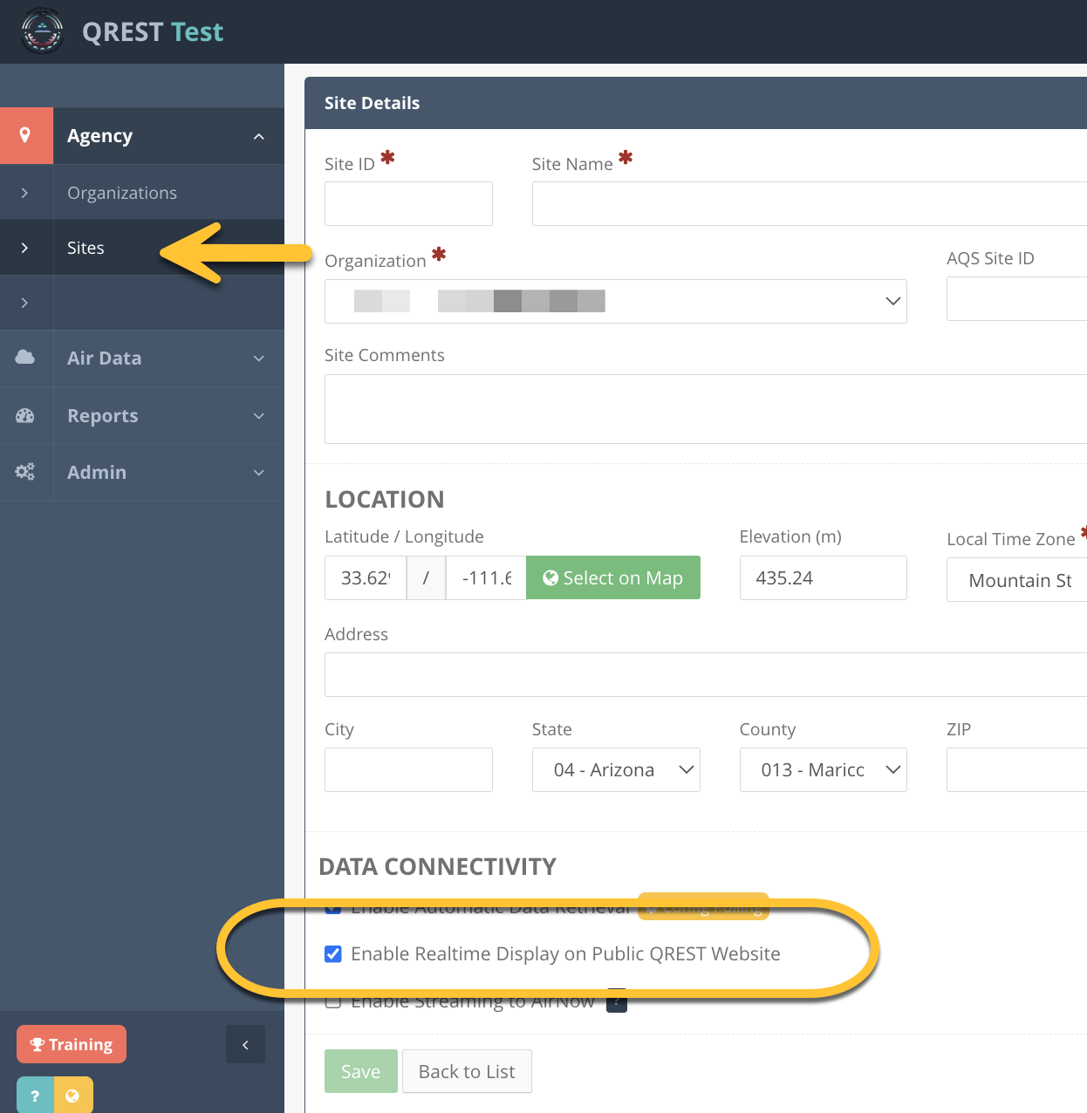

The Client can use this map as a jumping-off point to run various reports for the sites. These reports are described in sections 11.2-11.4.

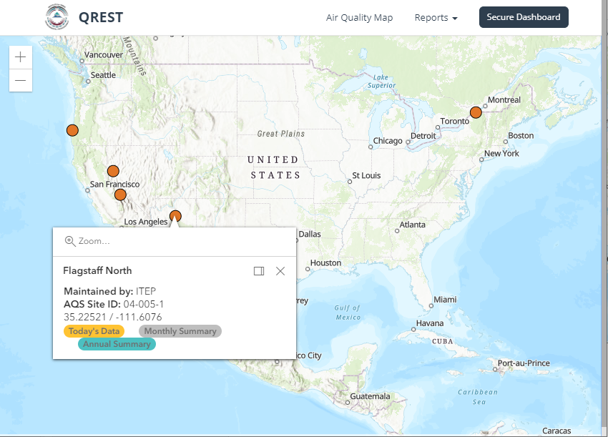

The Client can hover over the site to display general site information and use links to run reports for the site.